Chapter 5
ANN IMPLEMENTATION IN EXCEL
5.1 Implementing Neural Networks using What-If Analysis & Solver Optimization
In this chapter we show how the whole logic of neural network can be implemented in excel platform easily using two feature add-ins of Microsoft Excel- “What if analysis” and Solver. As mentioned in the previous chapter the design of a network starts with preprocessing the input, training the system with these inputs and then testing and implementation. The main Microsoft Excel functions which are used to implement this logic in excel includes, INDEX function, which is used to get the array value located at a certain row and column value. This function takes Index table range, row and column as input. The SUMPRODUCT is another function which is used to calculate the response of a neuron. As the name says it gives the sum of product of two ranges of values which are given as input to this function. The nonlinear function required in the case of perceptrons is the sigmoid function, for which an exponential term comes in its denominator. This is created by using the inbuilt function EXP functions available with Microsoft Excel. The following explanations shall provide an insight into how a neural network layer and its outputs are modelled inside MS-Excel.
Step 1: Obtaining Training Data & Initializing weights
Create a data table in Excel, with predefined number of feature values, as available from the training data provided for the neural network. This is shown in figure 5.1.
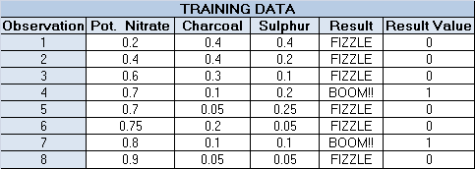
Fig 5.1: Training data table
Now the training data provided in the data table shown in figure 5.1, has to be taken one by one and the response of neural network for each set of inputs are calculated as follows. Each training data vector values are obtained from the data table shown in figure 5.1, by using INDEX function. E.g. the formula typed in the cell corresponding to cell “X1” is =INDEX ($B$8:$D$18, $I$7, 1). Here $B$8:$D$18 refers to the training data table range, $I$7 refers to the row index, [which is obtained from the cell corresponding to the label “Obs.INDEX” in the figure 5.2] and 1 is the column index. This is done for all other cells X2, X3 etc.
Now once we change the Obs.INDEX value, all other attribute values for the observation will be correspondingly updated in the circled cells as shown in figure 5.2. For example, when the value of ‘Obs.INDEX’ is provided as 1 the selections of the three attribute values for Potassium Nitrate, Charcoal, Sulpher will happen from the first row our training dataset shown in figure 5.1. And when the ‘Obs.INDEX’ is provided as two, the selection will happen from the second row of the data table and so on.
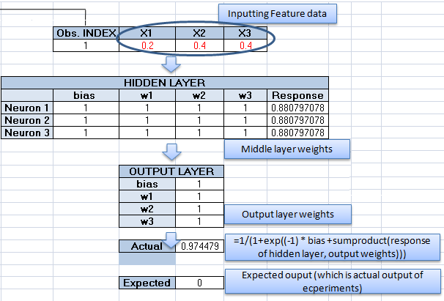
Fig 5.2: Input /Middle /Output layer
As you can observe, this model gives the output of just the first observation in a training set. We have to calculate the response in similar fashion for all the training data observations and this has to be done simultaneously`. This is where WHAT IF Data filling is used. Using the WHAT IF Data table function, we calculate the response for each observation in the training dataset, and then compare these responses to the actual values.
Step 2: Pre-requisite for What-If Analysis
Create a (“What if” data table) data table, with predefined number of observations, which is equal to the maximum number of observations in the training dataset. The actual response value as well as the expected value of the first observation is then stored in the column “Actual” and “Expected” value columns, against the first observation. The column “Error Square” is where we find the difference between the actual and expected output. Since we are having only 8 observations we restrict the row size of our data table to 8.
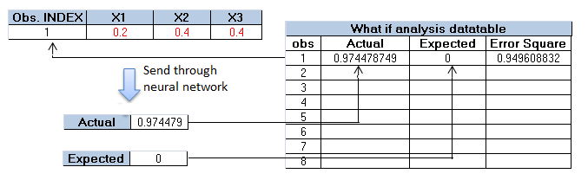
Fig 5.3: “What-if analysis” datatable

The figure 5.3 depicts the basic functionality of what-if analysis. The “obs” column in the whatif datatable has values from 0 to 8. As a prerequisite the first row is alloted with values as explained above. Keep it in mind that the formulas are written such that if you change “Obs. INDEX” the actual and expected response cell value changes. Select the entire table, and under the DATA tab of Excel, find WHAT-IF Analysis and then choose Data Table option.
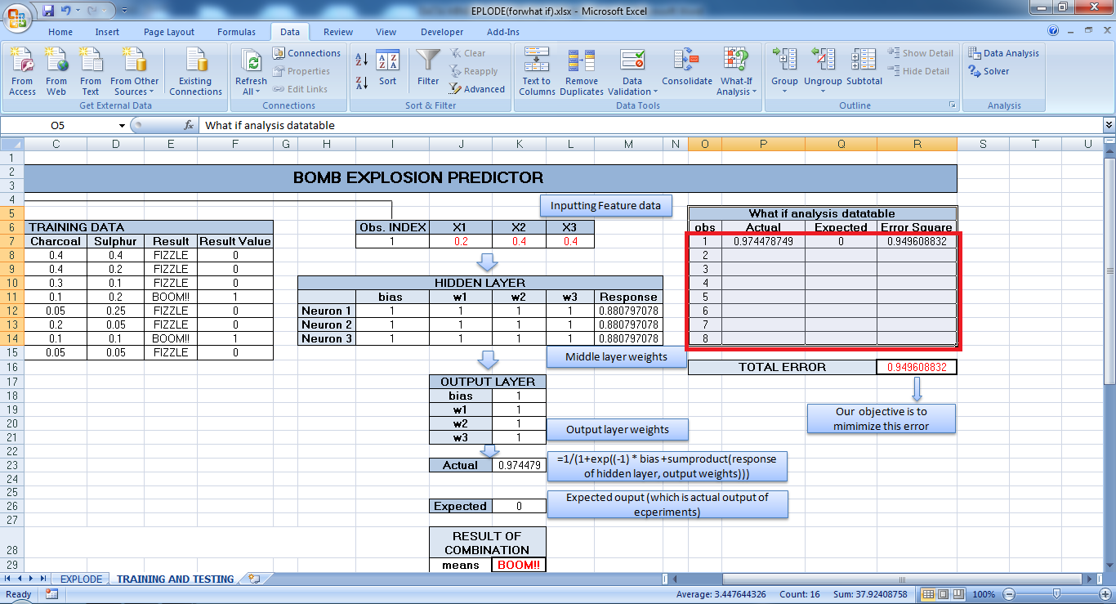
Fig 5.4: Screenshot: What if analyis datatable

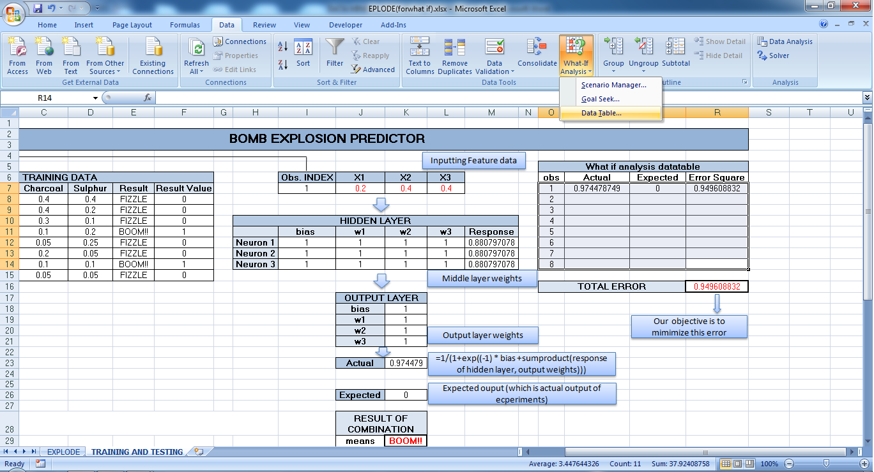
Fig 5.5: Screenshot: Opening “What if Analysis” tool
Step 3: Running What-If Analysis
In the argument acceptance box, give the cell address of the “Obs.INDEX” cell (i.e. $I$7) which is near the input feature array as the COLUMN INPUT CELL. There is no need to provide the row index as there is no second value to be changed. Now confirm by pressing OK. It will fill all the values(Actual and Expected) in the “what if analysis” data table. In the backend, what happens is it will apply the values available in “Obs” index, one by one, in the cell corresponding to the “Obs INDEX” and then obtain the response and print it in the last column of “what if analysis” datatable.
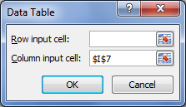
Fig 5.6: Screenshot: “What if Analysis” argument provision

Now, the response and actual value of the all the observations are obtained. Also calculate the values for the column “Error Square” which contains the square of the difference between the expected and actual value using the formula as stated as follows.
=IFERROR((Expected Val – Actual Val)^2,9999999)

The formula implies the calculatation of the square of difference between Expected and actual response, and in case of any error replaces the cell value by 9999999 (error may be caused due to numerical overflow). The squaring is done in order to avoid any negative terms which will cancel out error values when we add them together. [Also minimization of sum of squares of individual terms is equivalent to minimization of sum of individual terms].

Step 4: Total error calculation
Enter the previously mentioned error formula in the first cell of the “Error Square” column, then take the mouse pointer to the right bottom corner of the cell. Click and then drag down to completely fill the diff^2 column. Then find the sum of all the values in the “Error Square” column.
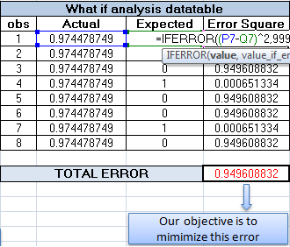
Fig 5.7: Total error calculation
Now “Solver”, the inherent optimization tool in Microsoft Excel is being used to minimize the sum of diff^2 so that the difference between the response and actual value for each training observation is reduced to the minimum level, and hence the network learns. The Target Cell to be minimized is set as the cell containing the sum of the diff^2 column (It is highlighted as Red in the figure 5.7 . The changeable Parameters are the bias and the weights of the neurons in the hidden layer as well as in the output layer. The task to be accomplished with respect to the Target cell is set to “Min” or minimization. And the solve button is pressed to perform the optimization [4]. The following screenshots (Fig 5.8) helps in better understanding of the above mentioned process.

STEP 5: Error minimization using ‘Solver’
The cell highlighted in red in the figure 5.8 shows the total error to be minimized in this case.
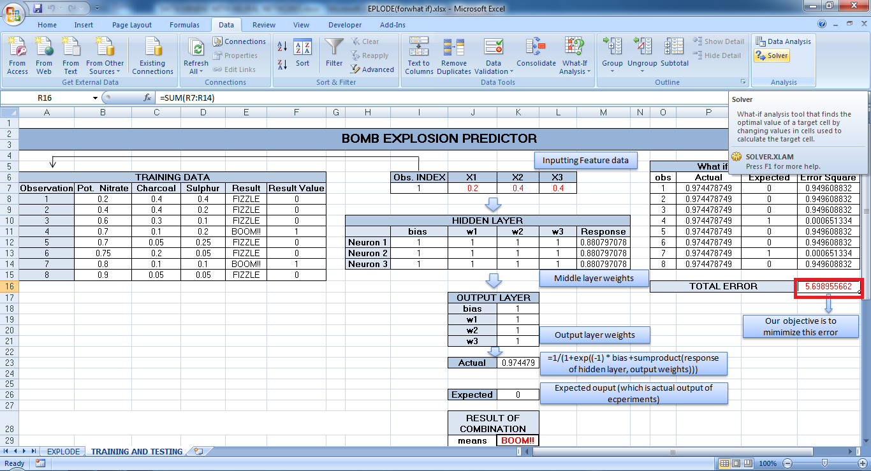
Fig 5.8: Screenshot: Total error minimization
The Solver configuration window (fig 5.9) will pop-up once the solver button is clicked. Here one need to select the problem type (minimization or maximization) and also cell address of the objective function, the cell address of the cells to be changed while optimizing and the constraints.
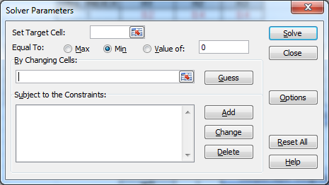
Fig 5.9: Solver tool
First of all select the optimization problem type i.e. minimization/maximization. In this case it is the error minimization. So in the cell corresponding to “Set Target Cell” (objective function value) provide the address of cell containing the previously calculated Total Error.
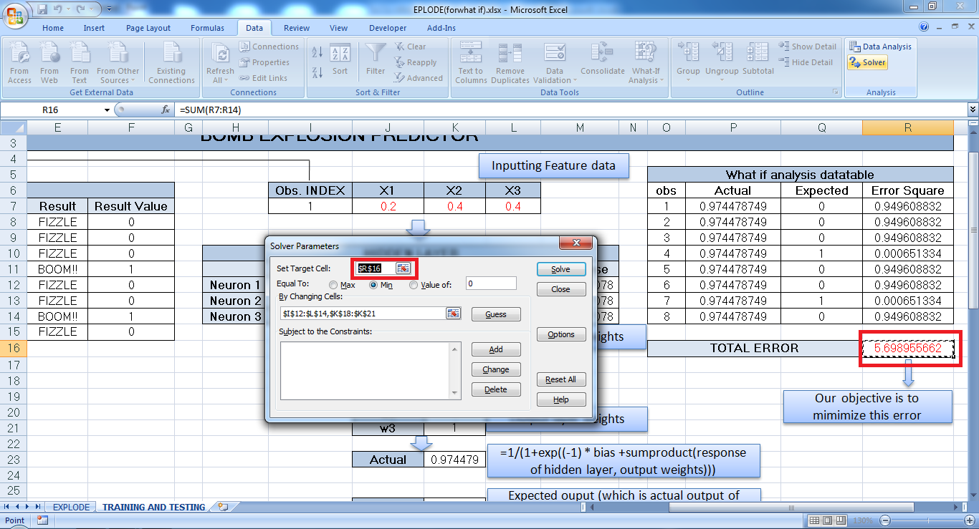
Fig 5.10: Screenshot providing target cell address for solver
Now select the changeable set of cells and also select the constraints. For this case since there are no constraints one can do without providing the constraints. Figure 5.11 shows the solver parameter window filled with the required parameters
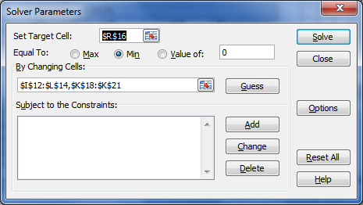
Fig 5.11: Solver tool (with provided parameters)
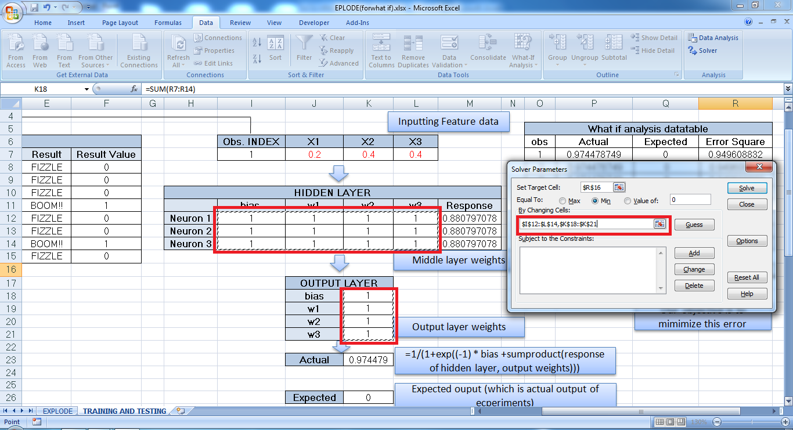
Fig 5.12: Screenshot: Provision of changeable cell address
Set the “Equal to” option to Min to perform the minimization and the press the solve button, in order to obtain the trained neural network weights. Now we will get a screen as shown in Figure 5.13. Select the “Keep Solver Solution” radio button and click OK.
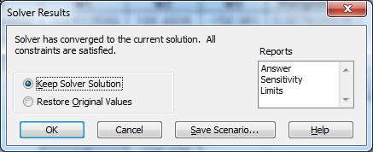
Fig 5.13: The Solver result screen
We will now get the optimized set of weights as shown in the figure 5.14. Now here we can see that the “TOTAL ERROR” in this case it is a minimum. Thus we have our neural network trained.
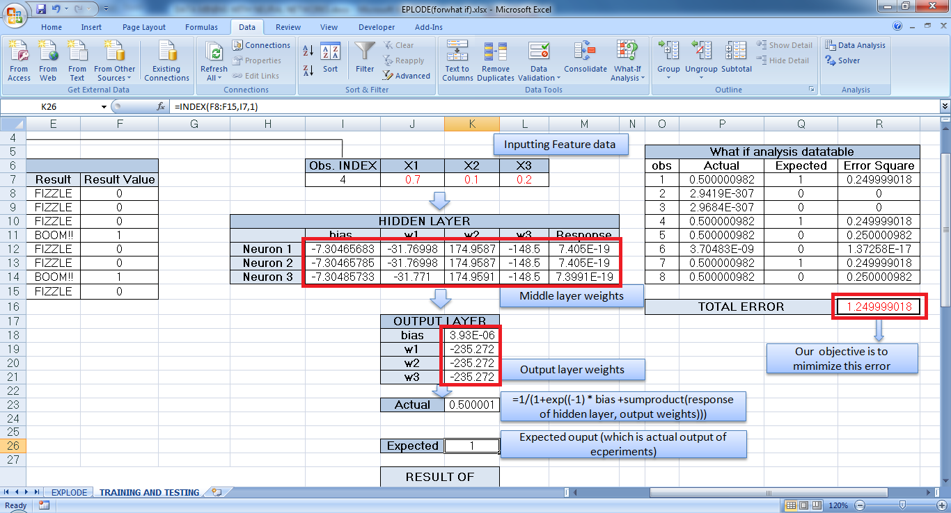
Fig 5.14: Optimized weights
Now we can test the system by giving any test data for which we know the result. Thus by providing the concentration of Potassium nitrate, Charcoal and Sulpher we will in a position to predict the output of the reaction.(ie, it explodes or not).
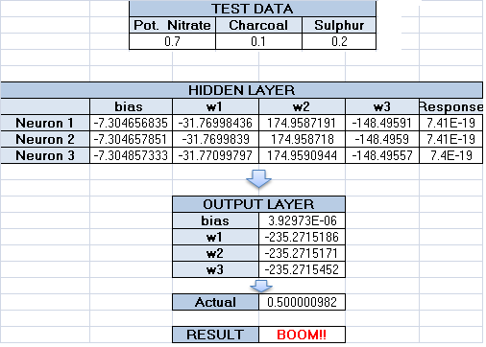
Fig 5.15: Final Output

- Implementations Using ANN
As we know, Neural Networks are non linear data driven self adaptive approach as opposed to the traditional model based methods. They are powerful tool for modeling especially when even the underlying data relationship is unknown. ANN can identify and learn correlated patterns between input data sets and corresponding target data sets. After training the ANN will be able to inherit the logic existing between the input and the output data which was used for training it. To understand how exactly the ANN learns a certain logic we have implemented and explained some examples using ANN in Microsoft Excel.
5.2. XOR Problem
We saw in the previous chapter the inability of a linear classification process to create the response of an XOR gate and the way it was handled [5]. Here we are trying to train the neural network, the response of an XOR gate. The whole performance of a neural network depends upon the amount of training it had received before actual data is provided to it for classification. This section explains the steps involved in implementing XOR logic in excel.
5.2.1 Preprocessing
The first preprocessing step is to obtain training data. Here the training data available to us is the truth table data for an XOR gate. As shown in the case of an XOR the output will become 1 when the X1 and X2 are unequal and else the output will become 0.
Case | X1 | X2 | Y
1 | 0 | 0 | 0
2 | 0 | 1 | 1
3 | 1 | 0 | 1
4 | 1 | 1 | 0
Table 5.2.1: Truth table of XOR
The graph figure 5.2.2 is obtained by plotting the table, 5.2.1. Here the X axis shows the X1 value and the Y axis shows the X2 value.
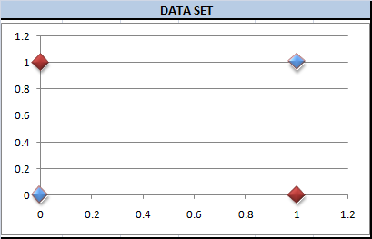
Fig 5.2.1: Distribution of XOR test data
The second step in the design of a neural network is to group the available data into training data and testing data. In our case we have used all the four available data from XOR has been utilized as the training data. (This is done due to scarcity of available data). The next step is the selection of network architecture. Here we are going for multilayer perceptron, due to its ability to solve nonlinear problems. The number of input nodes in the input layer is two in the sense that we have only two inputs for an XOR gate. Here we only have one middle layer (since the operation is comparatively simpler) with three middle layer nodes. The output of neural network is expected to give a value 0 or 1. For this reason we need only one node in the output layer.
5.2.2 Training Phase
The training is the process of obtaining a classifier which could easily separate the data set belonging to each class. For the XOR, the classification cannot be done using a linear classifier but a non linear classifier. This is what we call as XOR problem. The primary process in a neural network is the training process. In case of neural network platform, training is the process of adjusting the weights of a neural network until the misclassification error is minimum.
NOTE
Why can’t we make the error 0? This is almost possible in real but this will trigger a problem called over fitting which cause misclassification problem.
There is a pivoted statement above saying that the training of a neural network requires large amount of data. But as we can see; all we have is a group of four inputs. So all we can do it repeatedly give these four inputs until the network get trained. One should try giving the trained data as inputs and stop at that point when the misclassification error is a minimum. But how will know, at what point the neural network will get trained? Unfortunately there is no other option except to go for a trial and error process by going for different initial weights.
- Initializing the middle layer/output layer weights & bias values
The middle layer weight and the bias value is what control the decision process of neural network. As a starting point what we do is initialize the middle layer weights with random values or as all 1’s.[It should be kept in mind that the solver (An excel add-in used for solving an optimization problem) will sometimes end up with the different final weight values even for same set of inputs and initial weight values; So the only possibility to get the optimal set of weight values to try giving different initial weight values until the optimal weights are obtained.] The same way the output layer weights are also initialized. The initial status of middle/ output layer weights is shown in fig 5.2.2. Since this is a simple optimization problem the effect of initial weighs on locating the optimal set of weights is very less and hence all the weights were provides the value 1.
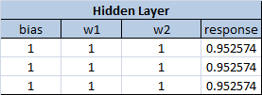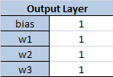
Fig 5.2.2: Initial Hidden Layer/Output layer weights
First of all the four XOR truth table data is given repeatedly for more than 4 times. The output given by the neural network is compared with the expected output (which in case is a 0 or 1) for each of the input and the error (expected response – actual response) value is obtained for each of them. Now add up all the error values to obtain the total error in the training [4]. This process is shown in figure 5.2.3
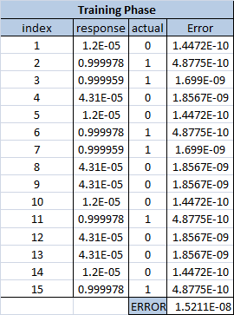
Fig 5.2.3: Total Error
Now our objective is to find the set of weight/ bias values for which we can minimize this total error. Now the question would be how would we adjust the weights and find an optimum set of values which would minimize the error value [4].
- Adjusting middle layer/ output layer weights
This adjustment process is really a tedious task if we are doing it manually. But luckily we have tool named “SOLVER” which is available by default with Microsoft Excel. This tool is basically an optimization problem solver which takes in an objective function and a set of constrains as inputs and provide an optimum solution to us. The middle/output layer weights along with the bias terms are adjusted by the “SOLVER” itself and the error value is obtained. This process is continued a large number of times until “SOLVER” finds that the error values are not getting affected much (less than the user defined tolerance value) even with the change in the weight/ bias values or the number of permitted iterations is exceeded [4].
In this case the objective function is a minimization function which aims at minimizing the total error. Thus the cell address of the cell which contains the total error value is given as the “Target Cell” textbox. Now select all the cells whose values need to be changed or adjusted and give their range address to the textbox corresponding to the “By changing cells” label.(Since there are multiple ranges of cells to be readjusted, provide their range addresses separated by a semicolon. The figures 5.2.4, show the optimum values of weights/ bias obtained for the hidden layer and the output layer by using “SOLVER” for implementing XOR logic using ANN [4].
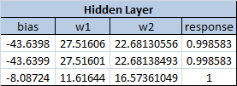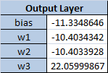
Fig 5.2.4: Optimized hidden/output layer weights
5.2.3 Testing Phase
Testing phase is where we test the extent to which the neural network has been trained. First of all the four XOR truth table data is given to the trained ANN. The output given by the ANN is compared with the expected output (which in case is a 0 or 1) for each of the inputs. If for all the inputs provided, the outputs are the expected outputs then we can say that the ANN is trained perfectly. For this case the testing phase showed no error.
Now we have trained and tested out neural network. The next part is to give values in between -2 and 2. [The XOR does not take values between 0 and 1, but here we are trying to check the ability of the neural network to classify for values other than 0 and 1 i.e. a value 1.2 should be considered as 1 and a value .5 should be considered as 0].
Here we are taking 40 values between -2 and 2 for both X1 and X2 inputs. For all set of inputs the output of the neural network is obtained and if the output is found to exceed 0.5 we print 1 to the cell against the corresponding X1 and x2 value else 0 is printed. Here in our case we have used the help of “WHAT-IF ANALYSIS” package available with Microsoft Word 2007 to do this operation for all the set of input values. The output of “WHAT-IF ANALYSIS” is shown in figure 5.2.5. The first column of Excel sheet shows the X1 value sets and the first row of excel sheet gives the X2 values. The 0’s and 1’s are printed as shown in the figure 5.2.5.
Fig 5.2.5
Obtained cell values (using what-if analysis)
Finally the color “RED” is given to the excel sheet cell having 0 and blue is given to the cells having values 1. This coloring is done using a small macrocode. The output of the coloring process is shown in figure 5.2.6
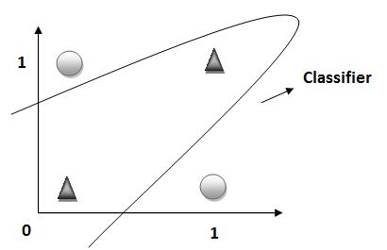
Fig 5.2.6: Actual & Expected classifier
From the figure 5.2.6, we can interpret that the classifier obtained from the figure 5.2.6 is almost matching. Hence we can conclude that the neural network has been trained perfectly to identify and classify an XOR input.
5.3 Classification of Circular Dataset
Have you ever thought about the sought of data distribution of height vs. weight of 100 people. For testing purpose, just try to plot the height vs. weight distribution for 100 people. It will have a shape of an ellipse. This is due to the reason that there will be no or very less number of persons with height greater than 7 feet and weight less than 50 kg. Also the number of people having height as 2 feet and weight as 100 kg will also be very less. Similarly all real world datasets have some inherent pattern in them. If one could understand this pattern in the data distribution it is always possible to separate out these datasets from other datasets by using a classifier. And once we have a classifier generated any new data can be classified to their corresponding classes.
For time being let’s assume the case of a circular dataset. Using neural network it is possible to classify such data. Here circular data set implies to any 2 classes which can be separated using a circular classifiers. Since we are out of real circular dataset we can generate a circular data set as shown figure 5.3.1 by the following procedure.
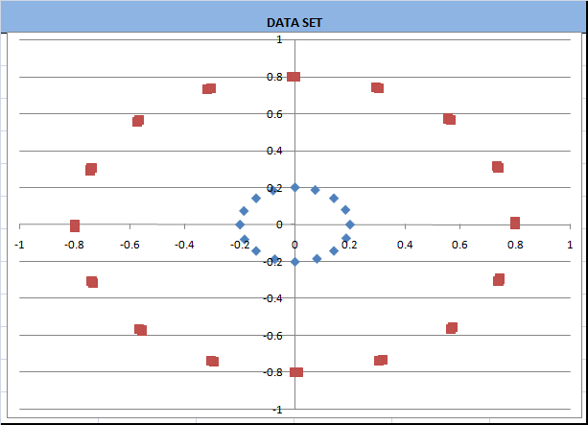
Fig 5.3.1: Circular dataset
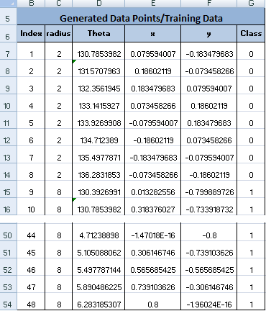
Fig 5.3.2: Training data (Generated dataset)
5.3.1 Prerequisites
A) Dataset Generation
Assume two radiuses (2 and 8) in column B to set the radius of two circles. Now we need to generate data points from these assumed circles. Here we take points uniformly from circumference points of circles of radius 2 and 8 with their centers at [0, 0]. And then it is normalized to a range [0 1]. For this angles (theta) are obtained using the formula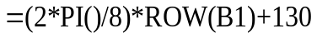. The X and y coordinates are obtained by using the formula 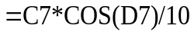 and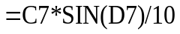. The generated values for Theta X, and Y is shown in the figure 5.3.2 [5].
B) Network Design and Architecture
Here the network takes two inputs, which are the X and Y coordinates of circular dataset. So the input layer should have two nodes. The amount of processing required for classifying two concentric circular dataset is small when compared to classifying other datasets. So in this case we go for single middle layer with 2 nodes. The expected output in this case is only a 0 or +1 which means that the output layer can do with one node. We use sigmoid function at end of all layers to restrict the output from each layer to a value in range [0, 1]. And about the architecture, here we are going for multilayer perceptron, due to its ability to solve nonlinear problems
5.3.2 Training/Learning Phase
As in any case of supervised neural network learning, we provide the generated circular data set as the training input. For favoring the “What if analysis” which is done at the end, we need to take the training data one by one and figure 5.3.3 is a setup which allows to do the same. In the excel sheet, we provide the index value of the interested row in the “Index” column. Once the index value is provided, the corresponding X1 and X2 values from the table shown in figure 5.3.2 will be populated at the X1 and X2 columns here.
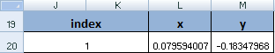
Fig 5.3.3: Input dataset
The next objective is the error calculation. Total error refers to the sum of, difference between the actual output and expected output for all the training inputs. This total error has to be minimized by adjusting the middle layer and output layer weights. This was achieved using “Solver” add-in available with Microsoft Excel. Here we stopped solving, when the total error was around 15. (It is always possible to reduce this error to a factor less than 5, which will give better classification results, but it is difficult achieve with the version of “Solver” available with Microsoft excel).
NOTE
To obtain a better results i.e. to reduce error, try providing multiple middle layers, and different initial weights
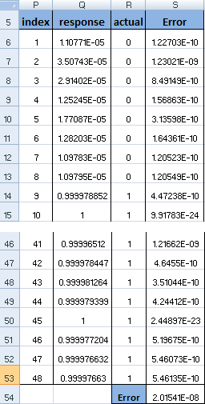
Fig 5.3.4: Total error detection
- Initializing the middle layer/output layer weights & bias values
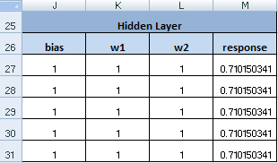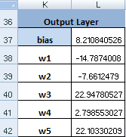
Fig 5.3.5: Initial middle layer/output layer weights
The middle layer weight and the bias value is what control the decision process of neural network. As a starting point what we do is initialize the middle layer weights with random values or as all 1’s. In the same way the output layer weights are also initialized. This is shown in the figure 5.3.5
- Adjusting middle layer/ output layer weights
As mentioned earlier, the “SOLVER” takes over the tedious task of adjusting the middle layer and output layer weights to mimimize the total error. This adjustment process is really a tedious task if we are doing it manually. “SOLVER” is basically an optimization problem solver which takes in an objective function and a set of constrains as inputs and provide an optimum solution to us. The middle/output layer weights along with the bias terms are adjusted by the “SOLVER” itself and the error value is obtained. This process is continued a large number of times until “SOLVER” finds that the error values are not getting affected much even with the change in the weight/ bias values or the number of permitted iterations is exceeded.
In our case the objective function is a minimization function which aims at minimizing the total error. Thus the cell address of the cell which contains the total error value is given as the “Target Cell” textbox. Now select all the cells whose values need to be changed or adjusted and give their range address to the textbox corresponding to the “By changing cells” label.(Since there are multiple ranges of cells to be readjusted, provide their range addresses separated by a semicolon. The figures 5.3.6 and 5.3.7, show the optimum values of weights/ bias obtained for the hidden layer and the output layer by using “SOLVER”.
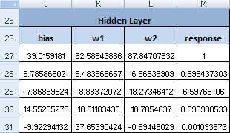
Fig 5.3.6: Optimized middle layer weights
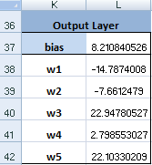
Fig 5.3.7: Optimized output layer weights
5.3.3 Testing Phase
We do not have any valid test data. So we provide points which are close to the input training data and check if it is being classified correctly.ie. Those points close to a particular training data should be classified to the same class to which the training data belongs to. The obtained circular classifier in this case was just able to classify the input data points.
NOTE
By generating more point from the circumference of the circle, and giving it as training data, we will be able to get a circular classifier.
Now we have trained and tested out neural network. The next part is to give values in between -1 and 1. Here we are taking 40 values between -1 and 1 for both X1 and X2 inputs. For all set of inputs the output of the neural network is obtained and if the output is found to exceed 0.5 we print 1 to the cell against the corresponding X1 and x2 value else 0 is printed. Here in our case we have used the help of “WHAT-IF ANALYSIS” package available with Microsoft Word 2007 to do this operation for all the set of input values. The output of “WHAT-IF ANALYSIS” is shown in figure 5.3.8. The First column shows the X1 value sets and the first column gives the X2 values. One can understand from the figure 5.3.8 that, the classifier (looks like a triangle).Even though we were expecting a circular classifier we got a triangular classifier which did the job of separating out the two datasets.

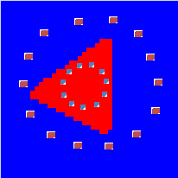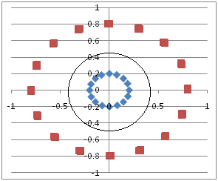
Fig 5.3.8: Actual & Expected classifier
  - Classification of Spiral Dataset
Spiral data set is one of the most complex data set which can be classified. It is always hard to find a classifier which could separate the two class points which takes the spiral distribution topology. Here let’s assume the case of a spiral dataset. By this example we can prove that, using neural network it is possible to classify such complex data distributions. Here spiral data set implies to any two classes which can be separated using a spiral classifiers. Since we are out of real spiral dataset we can generate a spiral data by the procedure said in section 5.4.1.
5.4.1 Prerequisites
A) Dataset Generation
For generating a circular dataset all we need to provide was a constant radius. The X coordinate of the point lying around the circumference of this circle of constant radius can be obtained by finding RADIUS*COS(Theta) and Y coordinate can be obtained by RADIUS *SIN(Theta). Here Theta is varied from 0 to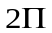. But here for generating a spiral dataset all we need to do it to provide a varying radius .
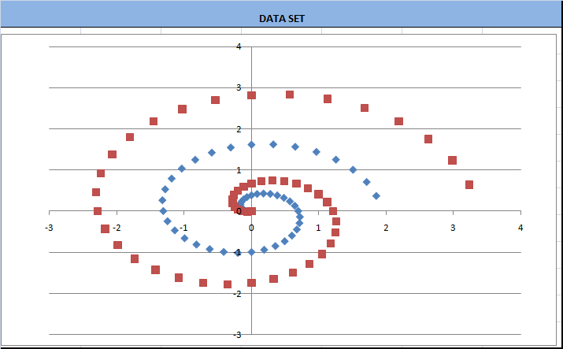
Fig 5.4.1: Spiral dataset
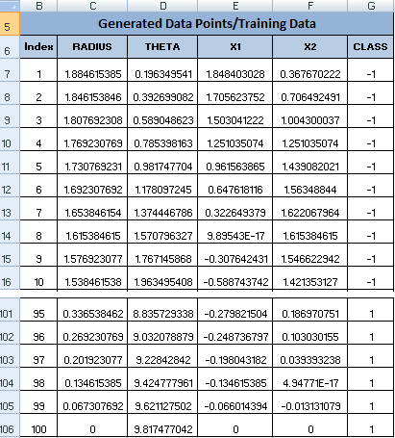
Fig 5.4.2: Training Data (Generated dataset)
The formula used for generating varying RADIUS can be =(4*(50-ROW(A1)))/104.[There is nothing to wonder on this formula; It just aims producing large change in RADIUS for successive points]. The X and Y coordinate can be obtained using same equation used for the circular case i.e. RADIUS*COS (Theeta) and RADIUS *SIN (Theeta). The formula used for obtaining different Theeta is =ROW(A1)*(PI()/16). [Here the factor 16 is used divide the total angle into 16 sections]. We only need to type these formulas in the first row and formula for rest of the cells can be obtained by dragging this through the required number of rows [5].
- Network Design and Architecture
Here the network takes two inputs, which are the X and Y coordinates. So the input layer should have two nodes. As mentioned, the spiral dataset classification is one of the complex tasks to achieve. For that we require a complex spiral classifier .The amount of processing required for classifying two entwined spiral dataset is comparatively large when compared to classifying other datasets. So in this case we go for two middle layers, one with two nodes and another with six nodes. The expected output in this case is only a -1 or +1 which means that the output layer can do with one node.
Note
In this case, we do not use sigmoid function for the output layer response. This is because of its in ability to produce negative values.

5.4.2 Training Phase
- Initializing the middle layer/output layer weights & bias values
As mentioned in the case of circular classification, we initialize the weights with random values. The final optimum solution (minima or maxima) is dependent on the initial weights which are chosen. So at this point a lot of trial and error is required to find out the optimal set of weights for which the solution reaches the global minimum and does not get stuck in the local minimum, while solving. For spiral data set the initial values have a pretty decent dependency on the initial weights.
As in any case of supervised neural network learning, we provide the generated spiral data set as the training input. For favoring the “What if analysis” which is done at the end, we prove the data in a particular format. In the figure 5.4.3, we use the index value as the first column. Once the index value is provided, the corresponding X1 and X2 values from the table shown in Fig 5.4.2 will be populated here.
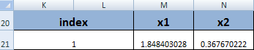
Fig 5.4.3: Input dataset
Our next objective is the error calculation. Total error refers to the sum of, difference between the actual output and expected output for all the training inputs. And we aim at minimizing this total error. This is done by adjusting the middle layer and output layer weights. Here we stopped solving, when the total error was around 55. (It is always possible to reduce this error to a factor less than 5, which will give better classification results).
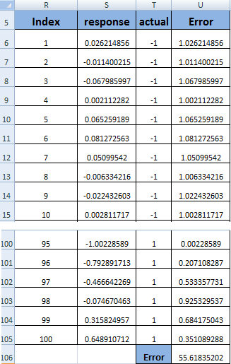
Fig 5.4.4: Total Error calculation
- Adjusting middle layer/ output layer weights
The “SOLVER” takes over the tedious task of adjusting the middle layer and output layer weights. This adjustment process is really a tedious task if we are doing it manually. “SOLVER” is basically an optimization problem solver which takes in an objective function and a set of constrains as inputs and provide an optimum solution to us. The middle/output layer weights along with the bias terms are adjusted by the “SOLVER” itself and the error value is obtained. This process is continued a large number of times until “SOLVER” feels that the error values are not getting affected much even with the change in the weight/ bias values or the number of permitted iterations is exceeded Thus the objective function is a minimization function. Thus the cell address of the cell which contains the total error value is given as the “Target Cell” textbox in solver. Now select all the cells whose values need to be changed or adjusted and give their range address to the textbox corresponding to the “By changing cells” label.(Since there are multiple ranges of cells to be readjusted, provide their range addresses separated by a semicolon. The figures 5.4.5, 5.4.6 and 5.4.7, show the optimum values of weights/ bias obtained for the hidden layers and the output layer by using “SOLVER [4][6].
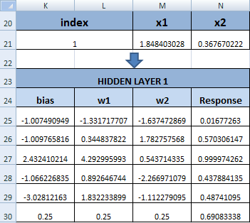
Fig 5.4.5: Optimized weights of Hidden layer 1
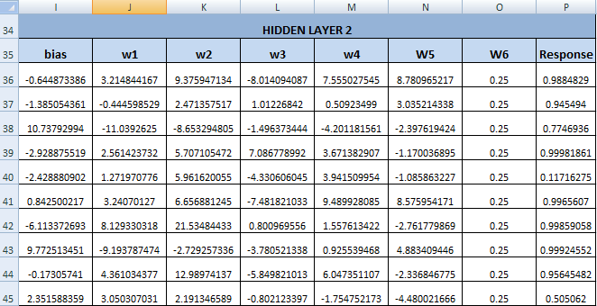
Fig 5.4.6: Optimized weights of Hidden layer 2
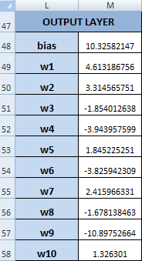
Fig 5.4.7: Optimized output layer weights
5.4.3 Testing Phase
We do not have any valid test data. So we provide points which are close to the input training data and check if it is being classified correctly.ie. Those points close to a particular training data should be classified to the same class to which the training data belongs to. The obtained spiral classifier in this case was just able to classify the input data points.
NOTE
By generating more spiral dataset points, and giving it as training data, and by trying out various initial weights, we will be able to get a better classifier. The classifier shown n figure 5.4.8 is not a perfect spiral.
Now we have trained and tested out neural network. The next part is to give values in between -3 and 3. Here we are taking 41 values between -3 and 3 for both X1 and X2 inputs. For all set of inputs the output of the neural network is obtained and if the output is found to exceed 0.4 we print 1 to the cell against the corresponding X1 and X2 value else 0 is printed. Here in our case we have used the help of “WHAT-IF ANALYSIS” package available with Microsoft Word 2007 to do this operation for all the set of input values. The output of “WHAT-IF ANALYSIS” is shown in figure 5.4.8. The First column shows the X1 value sets and the first column gives the X2 values.
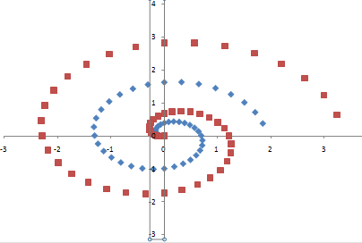
Fig 5.4.8: Actual & Expected classifier
  - Explosion Predictor
Bombs explode when the composed chemicals are mixed in correct composition. Lets us for time being take the case of a bomb where potassium nitrate , charcoal and sulpher forms its chemical ingredients . It is always possible to follow a composition ratio so that explosion can be made assured. Here we are aiming at making a machine learn by neural network algorithm. The networks is trained by providing it with the actual amount of potassium nitrate , charcoal and sulpher which has been used for creating a bomb and test results are also given. Based on this the neural network will train itself [6]. Once the neural network is trained the network will be able to predict the outcome when any combination of these chemicals are combined. The figure 5.5.1 shows the different combinations for which the testing has been done and corresponding outcomes. All the collected data should not be provided as training data. We must keep apart some data for testing also. For this case we have taken eight training data from the available eleven data value [Here we do not have a preprocessing].
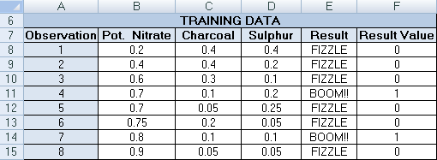
Fig 5.5.1: Training data
5.5.1 Training Phase
Here we have assumed that the there is only one hidden layer (with 3 neurons) and an output layer(with 1 neuron). For implementing neural network, we should first initialize the weights in the middle layer/ output layer, bias term with rand values or with 1’s. Now we need to adjust the middle layer weights such that for almost all the input combination (training data) almost the same response is obtained. For this purpose we calculate the error in each prediction and find the total error as shown in figure 5.5.2. The solver is used to find the optimum value of the weights for which the total error is minimum.
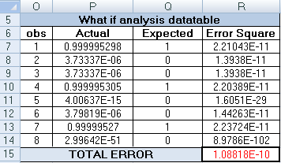
Fig 5.5.2: Error calculation
The figure 5.5.3 shows the 1st explode data. The index column on the left side shows the index number of data under consideration. [Along with each data in the training dataset we have an index number. See figure 5.5.3. This index term is included in order to facilitate the use of what if analysis in excel]. The quantity of potassium nitrate, charcoal and sulpher will get change automatically once we change the index value. This is done by using INDEX function in excel. It basically takes three arguments – the table range, the row of the table, column of the table and finally returns the value corresponding to that particular row and column in the table range. For E.g. The formula which need to typed in the cell corresponding to X1 can be =INDEX($B$8:$D$15,$I$7,1) where $B$8:$D$15represents the range of cells over which the table data spans, $I$7represents the index (row) and 1 represents the 1nd column of the referred table range. The same formula is used in all the other cells except that the column value changes. The column number in the formula should be changed for each of the successive three cells ie.1 should be made 3, 4 etc.
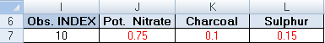
Fig 5.5.3: Input vector
Figure 5.5.4, shows the optimized weights for the hidden layer and the output layer. These optimized weights are obtained by using “SOLVER”. E.g. the formulae corresponding to the sigmoid function is =1/(1+EXP(-(I12+SUMPRODUCT(J12:L12,$J$7:$L$7)))) where J12:L12 shows the range of input value (ie. Quantity of potassium nitrate, charcoal and sulpher) and $K$7:$P$7 shows the range of weights cells in excel implementation. This is typed in the response column of the hidden layer section as shown in figure 5.5.4. Once the optimum weight values are obtained the response at the end column in obtained by taking the sum of, product of corresponding terms in the input layer values and weights in the middle layer W1, W2, W3 and then normalizing the value to the range [0 to 1]. This is done by using the signum function.
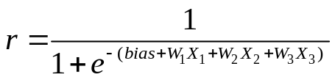
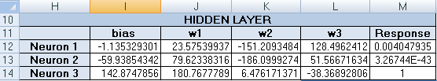
a)
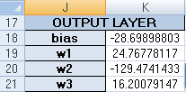
(b)
Fig 5.5.4: Optimized Hidden layer and output layer weights
The response obtained from the hidden layer is passed to the output later where this response is multiplied with the corresponding output layer weights, then added and normalized using the same equation mentioned in figure 5.5.4 (signum function). Now the response from the output layer will be a value between 0 and 1.

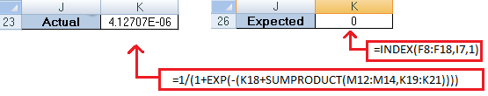
Fig 5.5.5: Actual &Expected Response

It can be seen that the actual and expected value when are almost close. The response from the output layer can be conveted to 0 or 1 by thresholding . Here threshold is set as 0.5. Thus if the Actual value is less than 0.5 the neural network predict the output as “Fizzle” and else , if it is below 0.5 neural network predict the ouput as “FIZZLE”. This is done by excel formula =IF(K23>0.5,"BOOM!!","FIZZLE") where K23 refers to the actual output value [4][6].

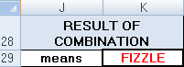
Fig 5.5.6: Final Output
5.5.2 Testing Phase
Now the neural network is trained. It is now time to test the output data. For this purpose we have kept apart 3 data values for which the output is known (i.e. from training dataset). We apply these data to the input of the neural network and if the neural network is found to give correct output we can say that the network is trained. Now it is ready to accept any input for classification [4][6].

  - Sine wave Interpolation
The sine problem is also taken from the NEURALYST software package but it has been modified and re-implemented using the method of WHAT-IF analysis and SOLVER [6]. In this problem, we are given few samples of the sine wave varying from 0 to 2π. This small number of samples acts as the training data. The neural network in this problem has to learn the mathematical relation between the input and output. Since we are considering a sine wave, the mathematical relation can be given as follows:
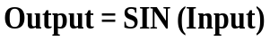
Hence, the neural network has to learn to provide the sine output for any input it receives. That is, for any value between 0 to 2π including those values which were not present in the training data the neural network has to generate a sine output.

5.6.1 Training data
The following table shown in figure 5.6.1 shows us the training dataset used in the sine wave interpolator example. It consists of an input value (X) and the corresponding output value (SIN(X)).
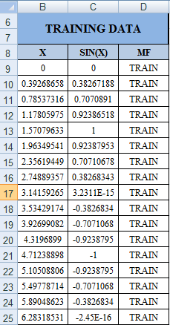
Fig. 5.6.1: Training data Sine wave interpolation
The training dataset contains 17 training pairs and they vary from 0 to 2π i.e. from 0 to 6.28. Now, based on these 17 inputs and their corresponding sine output, the neural network has to be trained so that if it is provided with any continuous value between 0 and 2π, it shall provide us the corresponding sine value. This typically means we have to interpolate for the corresponding mathematical relation in the given domain.
5.6.2 Neural Network Modelling
We start modeling the neural network structure inside excel by building initially an index table, which shall act as the input layer. Then we go on to build the hidden layer and the output layer. The index table like the input layer in the artificial neural network serves the only purpose of transcending the input feature into the working or hidden layer of the network and generate response in the hidden layer. These responses in hidden layer are then further transcended into the output layer, where it is used in deciding the final output response of the whole network.
Let us see how the index table is being created in excel. In our current example, which is sine wave interpolation, we have just one input that being the ‘X’ value from the training dataset (Refer the Fig.5.6.1). It is for this input that our neural network has to map into an output domain featured by a mathematical expression, as discussed earlier.
The index table contains a variable named ‘OBS’ and it indicates the observation number or the training pair number with respect to the training data set. Since our training data contains 17 observations, the value of observation number which is given in the cell just below the cell labeled ‘OBS’ can only vary from 1 to 17. Increasing it above 17 shall result in error. Adjacent to the cell labeled ‘OBS’ is the cell labeled ‘D1’ and this represent the first input feature. The cell below the one labeled ‘D1’ carries the value of the first input feature. This value is directly obtained from the training dataset’s input column (‘X’ column) by using the INDEX in-built function of MS-Excel and ‘OBS’ value as the index number/row number and the value ‘1’ as the column index number since we are considering the first ,and in this case the only, input feature. The formula in a generalized form shall be:
The following figures shall clear the remaining ambiguities, if at all.
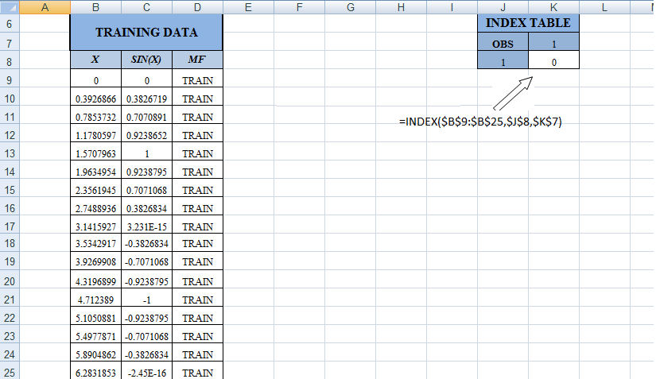
Fig 5.6.2: Creation of index table and the formula being used.

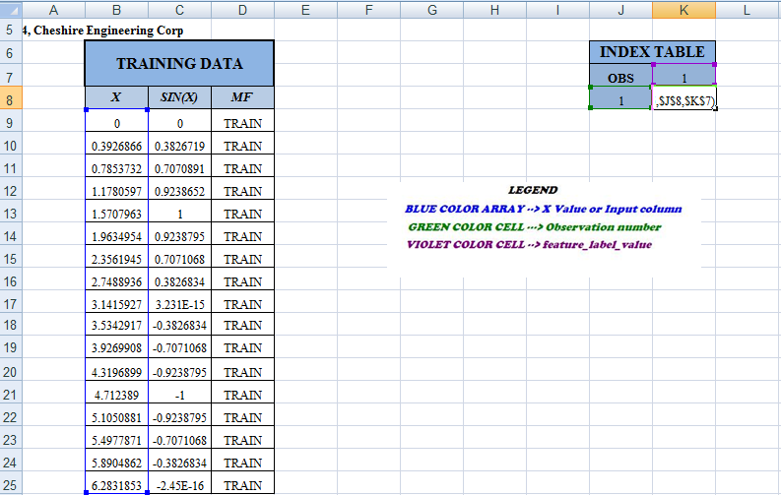
Fi`g 5.6.3: Creation of index table.(The formula parameters are color tagged)
Now that the index table has been constructed, we start creating the hidden and the output layer. The hidden layer consists of many neurons which actually does the learning. Here the number of hidden layer neuron is taken as 5.The number of neuron is usually found using trial and error methods. But as a rule of thumb, the number of the hidden layer neurons may be taken as the average of the number of feature in the input layer and the number of output layer neurons. The number of neuron in the output layer is based on the specific application. In binary classification type problems, usually a single neuron suffices. In our interpolation problem also a single neuron suffices, since the output is single real value.
For every neuron in the hidden or output layer there is an associated weight and bias. The number of weights in the hidden layer neurons depends on the number of input features. Since there is only one input in the interpolation problem being considered, there is only the requirement of a single weight in the hidden layer neuron. The number of weights in the output layer neuron will be equal to the number of hidden layer neurons. With these in mind, we create the hidden layer table and the output neuron table, with arbitrary values initially for weights and biases.
Usually the response of the neurons is calculated using an activation function. The activation function can be a sigmoid function or a linear function. Here we are using sigmoid function in calculating the responses of all the hidden layer neurons. The sigmoid function equation is given by:
Here, ‘EXP’ is the inbuilt exponentiation function in MS-Excel and ‘SUMPRODUCT’ is another inbuilt function in MS-excel used to calculate the sum of products of elements in two arrays. In the case of hidden layer in the interpolation problem, the two array input of the SUMPRODUCT function is the single element input feature from the index table and the weight value of each neuron and the bias corresponds to the bias value of each neuron [4][6].
Here, the response of the first neuron in the hidden layer is generated by the following formula: , where J12 is the cell range of the bias value of the first neuron, and the value K12 is the cell range representing the weight value of the first neuron. The cell range given by $K$8 represent the input feature value from the index table.
Modeling the output layer is similar to modeling the hidden layer but when it comes to the response value of the output layer neuron, there is a small modification in the response value formula (i.e. the activation function). Since we have to predict a continuous value in the domain [-1, 1] we have to use a linear activation function.
The response formula of the output layer neuron is given by the following formula:
Here the range of cells in excel spread sheet from K20 to K24 represents the output neuron weight array. The range of cells $L$12 to $L$16 represent all the response generated by the hidden layer neurons i.e. the response array. K19 represents the bias value of the output layer neuron. Thus this response is a linear one, without any exponentiation. Henceforth, it is capable of generating all values in the range between to . The cell containing the value labeled ‘Actual’ near to the output response value is obtained by indexing the value from the output or SIN(X) column in the training dataset based on the observation number. The above statements can be verified using the figure 5.6.4.

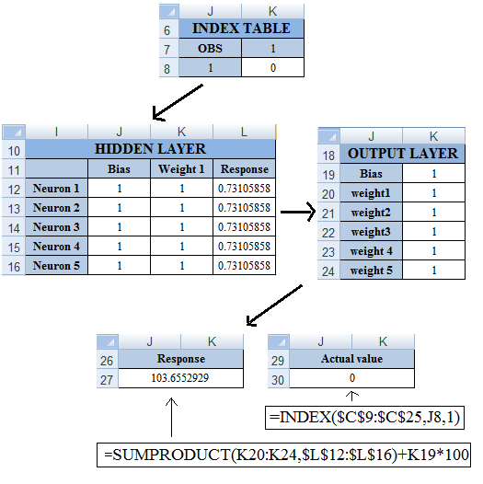
Fig 5.6.4: Initial Configuration
5.6.3 Training Phase
The neural network model that we have now modeled is only capable of providing the response for one input or for a single observation at a time. Hence to iterate the process for the rest of the observation numbers, we use the WHAT-IF analysis and fill a data table, such that we get the response and the actual values of all the 17 observations simultaneously. On getting this, we can find out the mean square error for each observation i.e. the square of the difference between the response and the actual value. Then the total sum of the “square of difference” error or total mean square error is calculated. In the training phase, as said in previous examples, the MS-Excel add-in called SOLVER is used to minimize this total mean square error by changing the weights and biases of the hidden and output layer neurons. On performing this task, and iterating the process of solving for different starting values of weights and biases in the neuron, we finally reach global minima for the error value. At this point, we can tell that the network has been optimized or the network has learnt.
.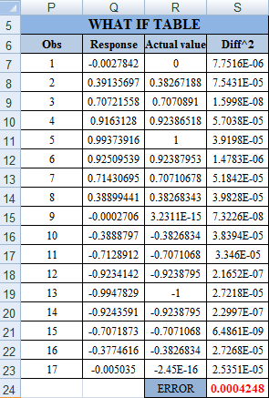
Fig 5.6.5: Total error calculation

Here the column Diff^2 carries the formula which calculates the mean square error between the response and the actual value. The formula is given by:
Here, if the mean square error value output given by “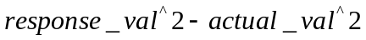” returns an error, then that position is replaced by a high value given by 999999. The total sum of error represents the sum of all value’s in the Diff^2 column. The table shown in figure 5.6.5 shows the error value being minimized to nearly zero. The corresponding optimized network is given by:
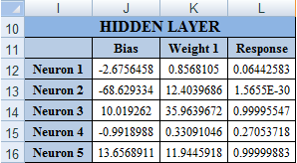
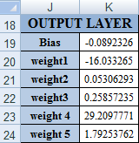
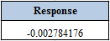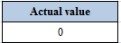
Fig 5.6.6: Optimized weights & response
5.6.4 Testing Phase
In the test phase, we recreate the neural network model, but this time, the index table is so created that the input feature value is taken from the column of input values ( ‘X’ ) of the test dataset and not the training dataset. That is, the input feature value is indexed out of the input column of the test data set based on the “OBS” value or observation number. Then this input feature value transcends the optimized hidden layer and the optimized output layer to generate the output response. An actual value near the output response value is indexed from the actual value column (‘SIN(X)’) of the test dataset based on the observation number or the “OBS” value of the index table. Again, the response value generated by the output neuron and the actual value, is created only for a single observation number and inorder to find the responses for all test data and compare them with the actual value already given by SIN(X) (where X is the input value) we create a WHAT-IF Data table. On doing so, we get the predicted response and the actual value for each observation in the test data side-by side for our comparison. In order to visualize and make the comparison effective, we plot each column using MS-Excel’s “Scatter plot, available with smooth lines” chart. The following are the output:
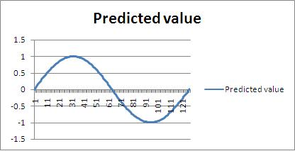
- Predicted response
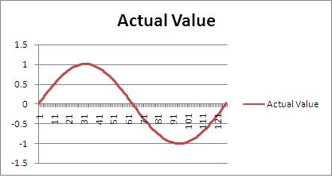
(b) Actual/Expected response
Figure 5.6.7
As we can observe, there is no much difference in the predicted output of the neural network and the given actual value. Hence forth we can say that this neural network has successfully learnt the mathematical formula which maps the input into the output domain [4][6].

  - Series Analysis
In series analysis, we literally try to predict the short term future or the trend of the data in the near future based on the collection of past data points. In our example we consider the prediction of the number line.
5.7.1 Training Dataset
Here we use three inputs 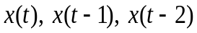 . The input signals 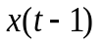 and 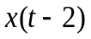are the time delayed versions of 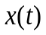. The signal is essentially the number line. It starts from 1 and goes on till 75. After a single time delay the value in is transcended into 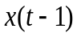 and after yet another time delay the value of transcends down into signal. (Refer figure 5.7.1)
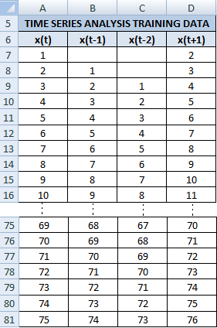
Fig 5.7.1: Training data
The actually training data begins at the point where all the input signals are filled. That means, the training data begins at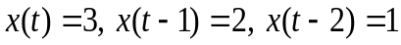 and extends till. The training data also contains the output column featured by the signal 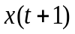 since we are considering a supervised class of learning. The learning problem can now be defined in terms of the input signals and corresponding output as follows: “The feedforward neural network has to take the three inputs and generate at its output the next value or the future value of which is given by”.
Thus we predict the future value of a signal , representing the number line, based on the current and two past value of the signal itself.
5.7.2 Modeling the Neural network
The feed forward neural network creation in MS-Excel for time series analysis is the same as other problems. We start with an index table, which corresponds to the input layer. In the index table, one cell is labeled ‘obs’. The value below this labeled cell is known as the observation number and helps in creating the index table. There are columns in the index table corresponding to the input features. Now using the training data, we can index the values of based on formula 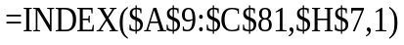,where INDEX is an inbuilt function in excel, $A$9:$C$81 represents the range of cells containing the training data set, $H$7 represents the cell range of the observation number and it shall act as the row number for the index function. The value ‘1’ in the formula represents the column number. Since is the first input feature we give the column value as 1. For signal inputs and we provide the same formula for indexing with the column number changed into 2 and 3 respectively. In this fashion, the index table is built.
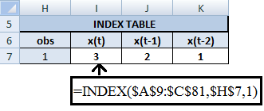
Fig 5.7.2: Creation of index Table
Next we start building the hidden layer and the output layer. The hidden layer and the or output layer neurons has associated weights and biases, and they generate a response based on a activation function which can be sigmoid or linear. We consider a hidden layer network here consisting of 12 neurons each having a bias and a three element weight array so that each neuron can receive the input values transcended by the index table or input layer into it. Initially value of the biases and weights of each neuron is set to 1 or any random value.
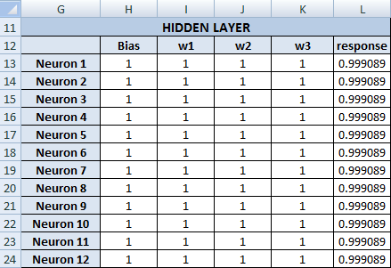
Fig 5.7.3: Initial hidden layer weights

Each neuron in the hidden layer generates a response based on sigmoid function. The following is the generalized sigmoid function:
Here, ‘EXP’ is the inbuilt exponentiation function in Excel and ‘SUMPRODUCT’ is another inbuilt function in excel used to calculate the sum of products of elements in two arrays. In the case of hidden layer, the two array input of the SUMPRODUCT function is the input feature array 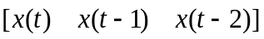 from the index table and the weight value 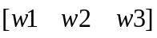 of each neuron. The bias corresponds to the bias value of each neuron.
For example, the response of the first neuron in the hidden layer is given by the formula where H9 is the cell range of the bias value of the first neuron, I9:K9 is the range of spreadsheet cells containing the weights of the first neuron. The spreadsheet cells ranging from $I$3 to $K$3 given by $I$3:$K$3 in the formula represents the values of from the index table.
Output layer, unlike the hidden layer, has just a single neuron since it has to predict just a single value which is . The neuron has single bias and 12 weight elements each corresponding to the 12 responses generated by the hidden layer. The response of the output layer is not characterized by the sigmoid function as in the hidden layer. It is because the sigmoid value can return only a value in the range [0, 1]. But we need continuous real number output at the output since we are trying to predict the number line series. Hence we use a linear activation function which is given as follows: where I27 is the bias value in the output neuron. The value on the spreadsheet’s range of cells I28 to I39 (given as I28:I39 in the formula) represents the 12 element weight array of the output neuron and the values in the range of cell given by $L$13 to $L$24 represents the 12 output responses from the hidden layer.
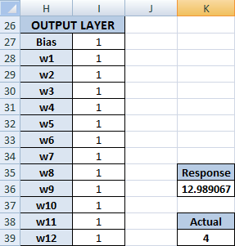
Fig 5.7.4: Initial output layer weights/ initial response for first training data
There is another value near the output response, called the “Actual” and it represents the actual or desired output response for the given observation number in the index table. The cell containing the actual value features the formula 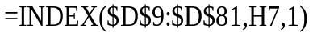 where $D$9:$D$81 represents the range of cells in the training data set which corresponds to the output value column. The value in the cell range H7 represents the observation number and the value ‘1’ represents the column number implying that the indexing should happen in the given 1st column of the given array $E$5:$E$77.
5.7.3 Training Phase
As we can see in the output layer figure 5.7.4, the response of the neuron doesn’t match the desired output. In training phase we essentially try to minimize this error difference between the response and the desired output. But the neural network we have modeled gives us the liberty of having only the response and desired output for a single observation number at a time. But our training data set contains 73 data pairs or observations. Hence to obtain the response for all the observations and compare them with the desired output in order to reduce the error, we perform the WHAT-IF analysis and create the WHAT IF data table so as to get find the mean square error i.e. the square of the difference between the response and actual value for all 73 pairs. Then we find out the total sum of mean square error. The objective is to minimize this total means square error by changing the weights and biases of the hidden as well as the output layer neuron. The following figure 5.7.5 shows the WHAT-IF data table with error which has been minimized. This minimization is done using the inbuilt SOLVER add-in of MS-Excel.
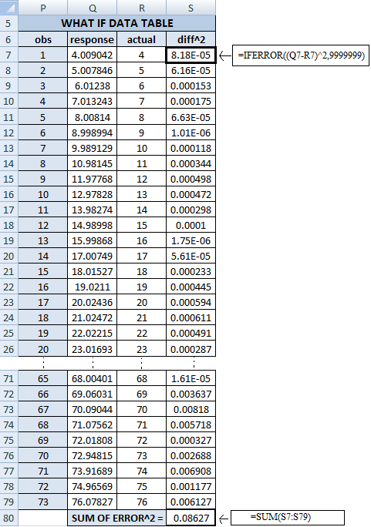
Fig 5.7.5: Total error calculation

The optimized hidden and output layers obtained after minimization of the mean square error s given in figure 5.7.6.
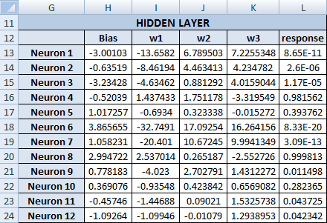
Fig 5.7.6: Optimized Hidden layer weights

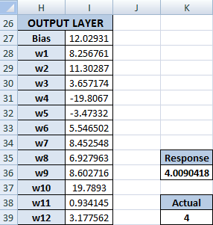
Fig 5.7.7: Optimized output layer weights/ response for first training data

From the figure 5.7.7, we find that the response generated for the optimized neural network now matches the desired output. Hence we can say that the network has been trained.

5.7.4 Test Phase
In the test phase, we find out the output values for a set of inputs which are included in our test dataset. The test dataset is given as follows:
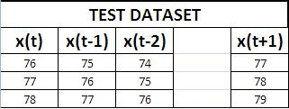
Fig 5.7.8: Test data

In the test dataset, the input features and the corresponding output.To test the neural network, we take the same optimized network that we created in the training phase and feed them with the input features of the test dataset and check as well as validate whether the response generated from the output layer of the network is same as the output given in the test dataset. If both are same, then we can say that the neural network has been successfully tested. Note that, in case of time series analysis, only short term predictions are possible. Hence forth any the neural network shall work only for the three cases mentioned in the test dataset. For any other input feature with greater value than that given in the test dataset, if given into the neural network shall yield a wrong output [4][6]. The following figure 5.7.9 illustrates an example of testing.

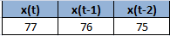
(a)
Input Layer
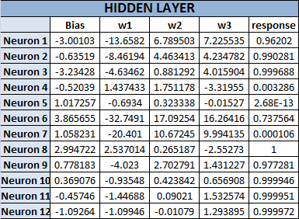
(b)
Optimized weights in hidden layer
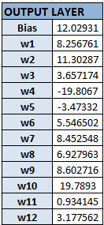
(C)
Output layer

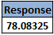
(d)
Response from output node
Fig 5.7.9
  - Mugbook
In this example, we have a criminal mugbook containing the details of some eight criminal. The details include their weight, age, sex, color etc. Each criminal has been given a unique tag number and a unique ID based on three binary values. The learning problem in this example is to use the training data to train the neural network in such a fashion that for a given input feature set, the neural network shall tell us, which unique ID (3 binary values) among the mugbook has the maximum correlation with the inputted features. For example, let us visualize a crime scene and a witness who gives us approximate features like sex, age, color and weight of the criminal who we shall refer to as Mr. X. Based on the obtained data from the witness, we shall find who among the criminals in the mugbook share the same or has the maximum correlation to the features of Mr. X. Instead of doing this manually, we employ a neural network to do this for us [6].
5.8.1 Training Dataset
The training dataset of the mugbook features the details of eight criminals along with their attributes or features like sex, age, color, and weight. The attributes are further characterized. Like sex can be either male or female. Color can be light, medium or dark complexions. Similarly weight is also characterized into light, medium and heavy based on bulkiness. Age is given in decades.
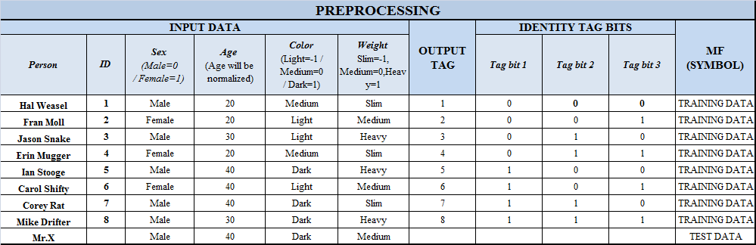
Fig 5.8.1: Training data
For each criminal, an identity tag bit from 000 to 111 has been assigned. This identity bits are the output labels for each training pair. It is the attributes/ features of each criminal like the sex, age, color and weight, which will act as the input data to the neural network for training. The only numerical data in the input dataset is age. All others are symbolic. Hence the preprocessing of the training data is required.
5.8.2 Preprocessing
In the preprocessing step, we convert the symbolic value in the training dataset, which has to be given into the neural network for training, into numerical value. For the attribute ‘sex’, we assign the value ‘1’ in case it is a ‘Male’ and ‘0’ in case it is a ‘Female’. For the attribute ‘Color’, we assign ‘Light’ as ‘-1’, Medium as ‘0’ and ‘Dark’ as ‘1’. Similarly for the attribute ‘Weight’, we assign ‘-1’ for ‘Light’, ‘0’ for ‘Medium’ and ‘1’ for ‘Heavy’.
The age is the only numerical value in the dataset and it is given in decades. But all the other features are in the range -1 to 1. Hence if we give the value of age in decades directly into the neural network, it shall cause errors, since it would always have a higher value than all other attributes. Henceforth the neural network decision may solely rest on the age value. To avoid this, we shall normalize the age and bring it down to the range -1 to 1.
On observing the age’s column in the dataset (Refer fig 7.8.1) we can find that the maximum value of age is 40 and minimum value is 20. To normalize the age, we do the following:
If the age of a person is ‘’ then, his normalized age for the current dataset is calculated as
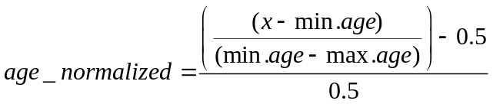
Here min. age is 20 and max. age is 40 as per the training data. For example if a person has age 30, then his normalize age would be calculated as
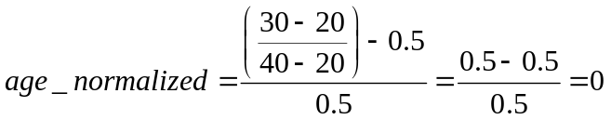
Henceforth a person with age ‘30’ has a normalized age of ‘0’, a person with age ‘20’ has normalized age as ‘-1’ and a person who has age ‘40’ has a normalized age of ‘1’ [6]. After preprocessing, the training dataset is given as:
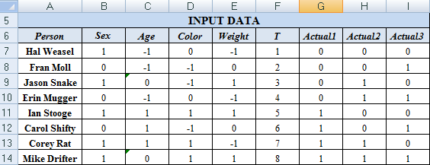
Fig 5.8.2: Preprocessed training data
5.8.3 Modeling the Neural Network
Here modeling the neural network is similar to previous examples (Refer example ‘EXPLODE’). We begin with an input layer or index table where in, based on the observation number, which is labeled as ‘Observation’, we shall index out each input feature from the training data.
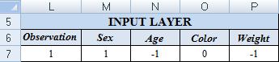
Fig 5.8.3: Index table/input layer

Now we model the hidden layer and the output layer. The only difference in this example, compared to the example EXPLODE is that the hidden layer has 6 neurons and the output layer has 3 neurons. The output layer has been modeled with three neurons so that each can give us as output a single tag bit of the unique ID of the person in the mugbook. The response of both the hidden layer as well as the output layer neuron is based on the sigmoid activation function which is given as:
Initially all the bias values and weights in each neuron of hidden as well as the output layer is initialized to 1 or some arbitrary value.
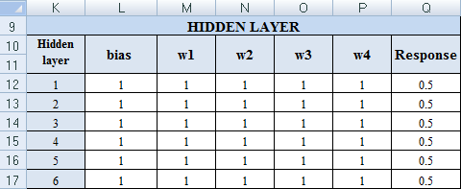
- Initial hidden layer weights
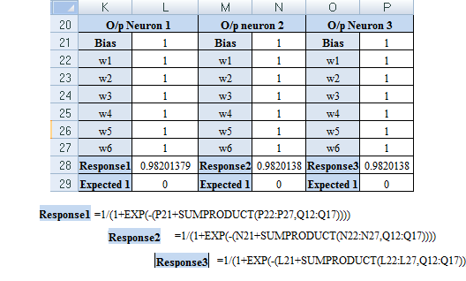
- Initial Output layer weights
Fig 5.8.4: Initial hidden layer/output layer weights
In each hidden layer neuron, the input feature array represented in the input layer gets multiplied with corresponding weights to form the sigmoid response. Since there are six hidden layer neurons we have six response values. These response values are taken by each output layer neuron and multiplied with corresponding weights so as to create three output responses.
The expected value, which is given under each output response (Refer figure 5.8.4) is directly indexed out of the output tag bit’s column based on the observation number. For eg : Expected1 is indexed out of the Actual1 column in the preprocessed training dataset. This expected value represents the desired output from the neural network for a certain observation.
5.8.4 Training Phase
The training is done by minimizing the mean square error between the response generated by the neural network and the expected or desired value by changing the weights and biases of the neurons. But this mean square error has to be reduced for all training pairs in the training data. The neural network model we have created shall give us the responses corresponding to only one observation or training pair but as said above, in order to train the neural network, we need to get the response value for all the training pair in the training dataset simultaneously. To get the response of all training pairs simultaneously, we perform the WHAT-IF analysis. Since we have three output neurons each having a response and corresponding desired values, we create three WHAT-IF data table and calculate the mean square error of each response with its desired output for all the training pairs.
For the three WHAT IF tables that are created we find the sum of mean square error between the response and the expected value. Then ultimately, a total sum of mean square error is found by adding the sum of mean square error calculated by each WHAT IF table analysis. This total sum of mean square error is then minimized by using the SOLVER addin in excel. The minimization is accomplished by changing the weights and biases of the neuron in the neural network. Since the error is being minimized, the reponse value and expected value starts to match and we say that the network weights and biases have been optimized or the learning process has been accomplished [4][6].
The following figure 5.8.5 shows the three WHAT-IF table with individual sum of mean square error corresponding to Response1, Response2 and Response3 respectively and the total sum of mean square error. The total sum of error is shown to have been minimized in the figure 5.8.5.
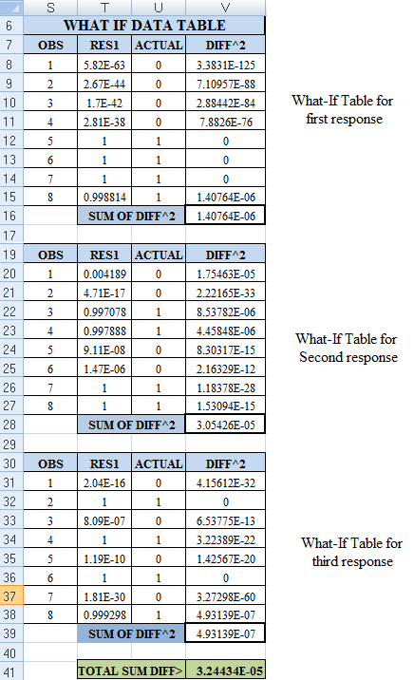
Fig 5.8.5: “What if “table responses
The optimized network with changed weights and biases is shown in the figure 5.8.6.
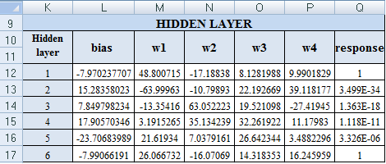
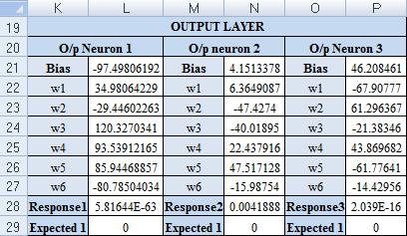
Fig. 5.8.6: Optimized neural network

Obtaining the optimized neural network marks the end of training phase. Now we need to move to the testing phase.
5.8.5 Testing Phase
As said in the beginning we have to find out the real identity of Mr. X by using neural networks which finds the maximum correlation between Mr. X’s features and the features of persons found in the mugbook. Hence the testing dataset contains the feature set i.e. sex, age, color and weight of Mr. X but not the output. By looking closely into the persons in the preprocessed training data we find that the maximum correlation for Mr. X is provided by person with unique ID ‘1’ ‘0’ ‘0’ and person with unique ID ‘1’ ‘1’ ‘0’. That is, Mr. X closely resembles the person with OUTPUT TAG’s 5 and 7. Now our neural network is not designed to make such subtle and fine distinctions between the outputs. So if the neural network provides us with any one of the answer i.e. either a tag ‘1’ ‘0’ ‘0’ or tag ‘1’ ‘1’ ‘0’ shall suffice and is considered to be correct. The following figure 5.8.7 shows the test data having attributes of Mr. X
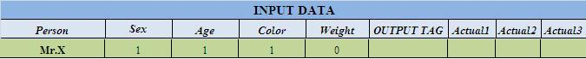
Fig 5.8.7: Test data
We now give this input feature of Mr. X into our optimized neural network and observe the result it gives us.
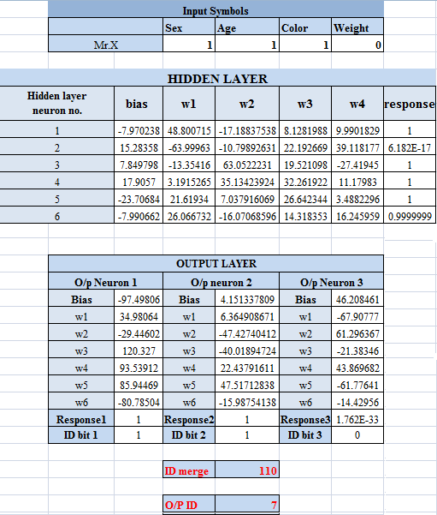
Fig 5.8.8: Response obtained for test data
The test output clearly shows us that the unique ID of Mr. X has been recognized as ‘1’ ‘1’ ‘0’ and the output tag ID is 7. Thus the neural network associated Mr. X with the 7th person in the mugbook who was one of the persons having maximum correlation with Mr. X’s features. Hence testing has been successfully accomplished and the neural network has associated the culprit to a person having maximum resemblance in the mugbook.
  - Square Pattern Recognition
Here a neural network implemented in MS-Excel (using WHAT-IF analysis without any use of macros) is used to tackle a pattern recognition problem. In this example, we have to detect if the given design or pattern of the order 6X6 contains a square made up of the symbol ‘X’ of minimum order 4 X 4. If there is such a pattern, then the shape of the pattern is recognized to be square, or else, it is considered to be a blob [3].
5.9.1 Training Dataset
The training dataset contains patterns which are created using 6 rows and 6 columns in the spreadsheet.
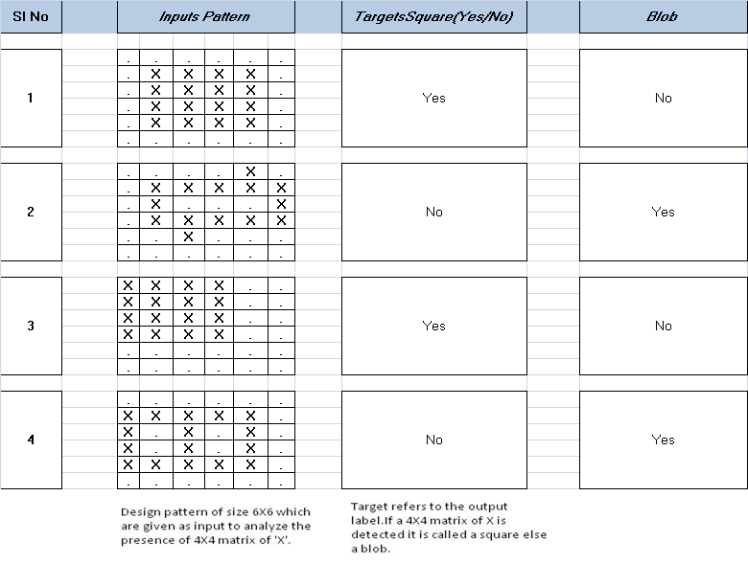
Fig. 5.9.1: Training data
Here the patterns are designed using two symbols ‘.’ and ‘X’, and they shall act as the input feature for the neural network. The learning problem as said previously is to detect if a given pattern of order 6X6, made of ‘.’ and ‘X’, contains a 4X4 matrix of X’s and without any ‘.’ in between them. Let us visualize some sample pattern from the training data for better understanding [6].
The targets column is the output label class and this is what the implemented neural network has to give out as result for future inputs/test inputs. Since there are only two classes of targets i.e. we have to classify the pattern as either ‘Square’ or a ‘blob’, this pattern recognition problem essentially reduces to a binary classification problem [6].
5.9.2 Preprocessing
In preprocessing stage, we have to essentially tackle the problems related to the training data and output target class both being symbolic, as well as, tackle the two dimensionality of the input feature. The WHAT-IF analysis can’t be performed for a two dimensional data directly. Since the creation of input layer or index table for 2D data management in excel is tedious.
Initially we convert all symbols in the training dataset in numerical values. The 2D input feature matrices are so converted that, ‘1’ represents ‘X’ and ‘-1’ represents ‘.’ This conversion is preferred over the using ‘1’ and ‘0’ as it gave better results in various cross validations. The target variable list is now converted into a single column where ‘1’ shall represent ‘SQUARE’ and ‘0’ shall represent a ‘BLOB’.
After obtaining the 2D numerical matrix, we convert this input feature into 1D by simply arranging the matrix is a linear row wise fashion. The 2nd row follows the 1st; the 3rd shall follow the 2nd and so on. Thus after preprocessing, the training dataset shall have 36 input feature or the feature vector shall be 1X36 and this is accompanied by the associated target class ‘1’ or ‘0’.
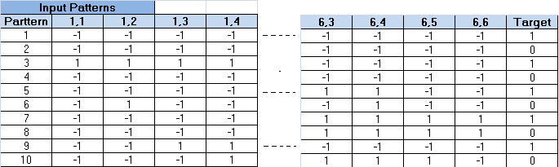
Fig 5.9.2: Preprocessed training dataset

5.9.3 Modeling Neural Network
Here modeling the neural network is similar to previous examples. We begin with an input layer or index table where in, based on the observation number, which is labeled as ‘Observation’, we shall index out each input feature from the training data.
Fig 5.9.3: Input layer

To explain the indexing using formula, we shall take the example of indexing out the value of ‘Feature1’ for the observation number. The formula used is ‘INDEX($V$5:$BE$14,$U$19,COLUMN(A1))’ where the cell range $V$5:$BE$14 relates to the preprocessed training dataset which contains the row wise arranged input features. The cell range $U$19 is the value of the observation number and acts as the row number for indexing. The column number used for indexing is given by ‘COLUMN(A1)’. As the formula is dragged across for the 1X36 length input layer, the column number value automatically changes from 1 to 36.
Now we model the hidden layer and the output layer. In this example, the hidden layer has 6 neurons and the output layer has 1 neuron .The creation of these layers is similar to those explained in previous examples. The response of both the hidden layer as well as the output layer neuron is based on the sigmoid activation function which is given as:
Even though the sigmoid activation function is being used here, the input feature value doesn’t remain the same for each neuron in the hidden layer unlike in other examples. Here the Neuron 1 of the hidden layer uses the first six values of the input layer as the input feature array; Neuron 2 uses the values from Feature7 to Feature12 in the input layer or index table. Thus each of the six neurons in the hidden layer gets one row of the original 2D matrix for processing and generating the response.
The output layer on the other hand, as usual, uses the response values generated by the hidden layer as its input feature array. Initially all the bias values and weights in each neuron of hidden as well as the output layer is initialized to 1 or some arbitrary value.
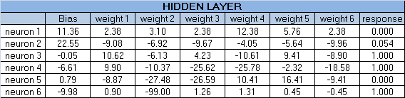
- Hidden Layer Weights

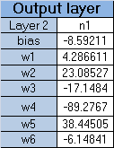
- Output Layer Weights

- Obtained and Actual Response(expected)
Fig 5.9.4

The ‘Actual’ value, which is given near the output response (Refer figure 5.9.4), is directly indexed out of the ‘Target’ column based on the observation number from the preprocessed training data. This ‘Actual’ value represents the desired output from the neural network for a certain observation.
5.9.4 Training Phase
In the training phase, like in the previous examples, we create a data table using WHAT-IF analysis since we have to get the output response from the neural network for all the observations in the training data simultaneously so as to calculate the mean square error (given by ‘diff^2’ column in WHAT-IF table) between the ‘output response’ and ‘Actual’ value. Training happens when we minimize the sum of mean square errors between the ‘output response’ value and the ‘Actual’ value of all observations. To minimize the mean square error, we use the inbuilt add-in in excel called the SOLVER. The solver shall minimize the mean square error by changing the weights and biases of the hidden as well as the output layers which was initially set to 1 or some arbitrary value. As error gets minimized the output response and actual value starts to coincide and our neural network generates the optimized hypotheses for the learning problem.
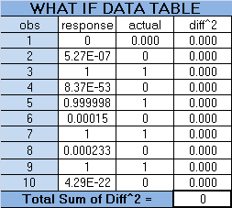
Fig 5.9.5: What if data table/ Error calculation

5.9.5 Testing Phase
In the testing phase we check the optimized neural network by using certain pattern similar to that used for training which the test dataset contains. The dataset has the pattern and it also knows which target class to which the pattern belongs to. Now in the test phase, each test dataset pattern is given into the optimized neural network generated after training, and the output of this neural network is compared to the target value already present in the testing dataset and thus the hypotheses learnt by the neural network is tested.
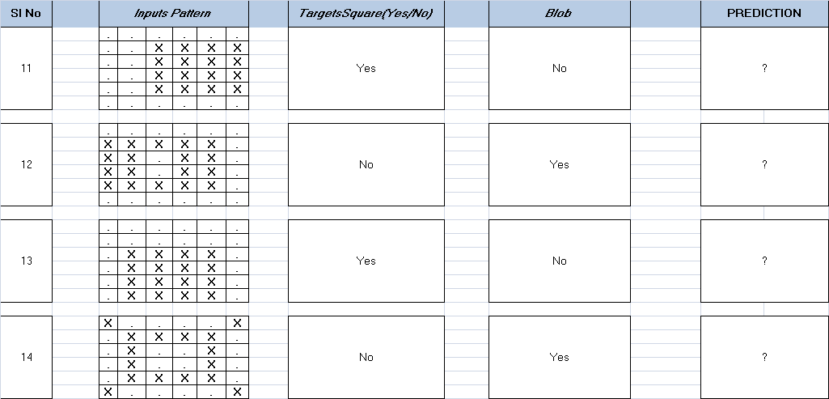
Fig 5.9.6: Test dataset
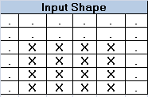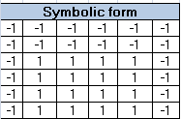
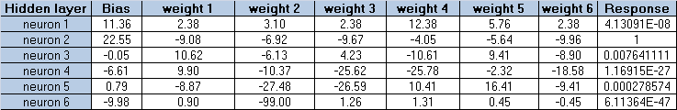
- Input Values/ weighted response

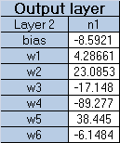
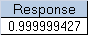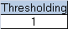

Fig 5.9.7: (b) Testing phase

It should be noted however that this neural network shall work only for the patterns given in the test dataset. For any other pattern that given to the neural network, it may give randomly varying results. This is because the training dataset has only about 10 samples for training the data and even though it is more than sufficient to explain this example, it is less than sufficient for proper supervised training for pattern recognition [4][6].
- Innovative Real Life Applications
Here we implement some real life problems using neural network, by first studying the problem, extracting features, designing a neural network and training it as per requirement.
  - The Eigen Ear
The security is a big issue in the modern world; it has become inevitable in case of finance sector with more number of fraudulence incidents. The only solution to avoid such incidents is by going for some methods by which a person can be uniquely identified like fingerprints, signs etc. But with the advancement of science the features by which a person can be uniquely identified also changed. Now the uniqueness of a person is found out by scanning his retinal structure, Ear pattern, DNA of person etc.
It is a fact that each individual has a unique ear structure. Here we are discussing the procedure by which the machine (computer) can be made to recognize a person uniquely by scanning ones ear. For authentication the features extracted from, the image obtained by scanning the ear is compared with those features extracted in prior. Ear pattern reorganization is the process of classifying unknown ear images to the set of available classes (ear pattern of different people). Here we are trying to make use of neural network to classify different ear images to corresponding classes; hence predicting the owner of the ear [1].
5.10.1 The Algorithm
Step 1: Mean and variance of the collected ear images are made almost equal using mean and variance normalization technique. Mean and variance of one of the image from the collections is treated as desired mean and desired variance.
Step 2: Reshape the matrix into the vector whose elements are collected column by column from the matrix [1].
Step 3: Co-variance matrix of the collected vectors is computed. Eigen values of the co-variance matrix and the Eigen vectors corresponding to the significant Eigen values are computed [1].
Step 4: Eigen vectors are reshaped into the matrix of the original [1].
Step 5: The Eigen ears are orthogonal to each other. They can be made orthonormal to each other by normalizing the vectors [1].
Step 6: For every ear image matrix, feature vectors are obtained as the inner product of eigen basis vectors and the reshaped ear image matrix [1].
Step 7: Mean vector of the feature vectors collected from the same person is treated as the template assigned to that corresponding person. This is repeated for other persons also. Thus one template is assigned to every person and they are stored in the database [1].
Step 8: To classify the unknown ear image as one among the two categories, template is computed as the inner product of Eigen basis vectors (Eigen ears) with reshaped normalized unknown ear image. The template thus obtained is compared with the group of templates stored in the database using Euclidean distance[1].
Step 9: Template corresponding to the minimum Euclidean distance is selected and the person corresponding to that template is declared as the identified person [1].
5.10.2 Implementation Details
An in any machine learning process, the feature extraction is the most important process. In this case, the eigenvectors of, the covariance matrix obtained by taking the picture of same ear at various lighting conditions forms the feature for a particular ear.
The algorithm in section 5.10.1 shows the step by step process involved in extracting the feature values for an ear. The first step involves the normalization of the pictures with which comes in as the training data. Here normalization refers to the centering the mean and variance of the pixel values in the picture to a desired level. The figures 5.10.1 show the mean and variance normalized images for 2 ear images.

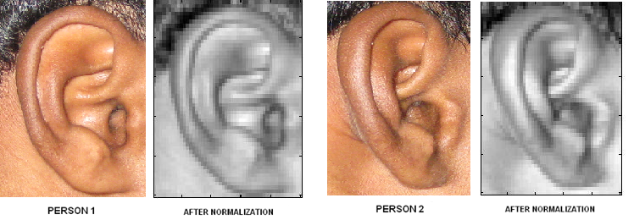
Fig 5.10.1: Normalized ear images [See attached CD for color images]

For training the Neural Network for identifying an ear, it must be given with the features acquired from the same ear at different lighting condition. For that we require photographs of the same ear at different lighting conditions and almost same angles. Out next step would be to find the covariance matrix from the different normalized images of the ear. For that all the image pixels for an image is printed in a single column using “reshape” command in Matlab. The pixel value of the next image is printed in the next column of a 2 x 2 matrix in Matlab. Now the covariance matrix can be found out using “cov” function available with Matlab. The independent eigenvector of this cross correlation matrix form the feature values for the first ear. This way features are found out for a second ear. Each eigenvector is a 1 x 6 matrix. For the sake of time, we have used MATLAB to generate the feature set for all the ears but it is possible to do the same thing in MS-Excel. [The implementation in MATLAB is provided in the attached CD].
With the help of Big Matrix (A third party add-in available for Microsoft Word) it is possible to do all matrix operations in Excel. With the use Excel macros it is possible to implement the whole logic of extracting the features from the given image. It is left as an exercise for you students to implements the logic using Excel Macros effectively.
5.10.3 Preprocessing
Being the first step in implementing a neural network, it has its own importance. The primary preprocessing step aims at separating the available feature data into testing as well as training Set. Here we have total of 10 feature data. Form that we have taken 6 feature data for training and kept apart 4 feature data for testing. The features here are eigenvectors which is having a dimension of 1 x 6.
5.10.4 Modeling Neural Network
The next main part in the designing of neural network is the selection of network architecture. Here we have chosen multilayer perceptron architecture. There are six input nodes for out input layer because the input vector is of size 1 x 6. There network is expected to find out the person to which the ear belongs! So a single output node is required in the output layer. As a rule of thumb, the middle layer is allocated N number of nodes, where N is the average of nodes present in the input and the output layer. Thus (6+1)/2=3 nodes are provided in the middle layer.
5.10.5 Training Phase
The next phase of the implementation deals with training the Neural Network with this extracted feature data. Here we have feature data for 2 ears. Here those eigenvectors belongs to person 1 are assigned class 0 and eigenvector belonging to person 2 are assigned with class 1. There are only six feature dataset for person1 and another six for person2 as training data they are repeatedly given for N number of times so that expected performance is achieved. Provide a class value as 0 for the first person and 1 for the second person.
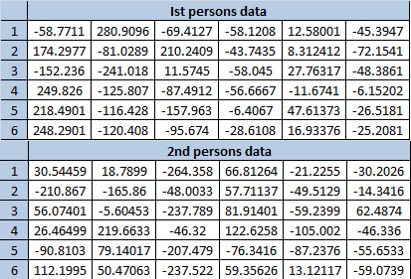
Fig 5.10.2: Training data
- Initializing the middle layer/output layer weights & bias values
As in normal neural network implementation, we should first initialize the weights in the middle layer/ output layer, bias term with rand values or with 1’s. The middle layer/ output layer weight and the bias value is what control the decision process of neural network. In the beginning we do initialize the middle layer weights with random values or as all 1’s. In the same way the output layer weights are also initialized. This is shown in the figure 5.10.3. To an extend the optimum solution point is dependent on the initial random weight values.
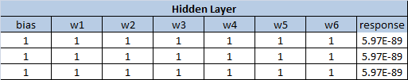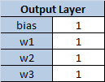
Fig 5.10.3: Initial Middle layer and output layer weights
- Adjusting Middle Layer/ Output Layer Weights
To find the optimum weights the an add-in named “SOLVER” which is available by default with Microsoft Excel is used. This tool is basically an optimization problem solver which takes in an objective function and a set of constrains as inputs and provide an optimum solution to us. The middle/output layer weights along with the bias terms are adjusted by the “SOLVER” itself and the error value is obtained. This process is continued a large number of times until “SOLVER” feels that the error values are not getting affected much even with the change in the weight/ bias values or the number of permitted iterations is exceeded. In our case the objective function is a minimization function which aims at minimizing the total error. Thus the cell address of the cell which contains the total error value is given as the “Target Cell” textbox. Now select all the cells whose values need to be changed or adjusted and give their range address to the textbox corresponding to the “By changing cells” label.(Since there are multiple ranges of cells to be readjusted, provide their range addresses separated by a semicolon. The response obtained at the output is normalized to a value between 0 and 1 using the following equation. An output 1 stands for first person and 0 stands for second person.
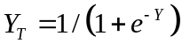
Where, y is the output of the neural network. If Y is very small e-^{y} will become infinity and the term Y_{T} will become 1 and when it is vice versa it becomes 0. Thus all the output value is normalized to value between 0 and 1 which forms the response of the neural network. At the end we will end up in a set of weight values for which, the neural network could correctly differentiate between features extracted from the first person and the second person i.e. whether the feature belongs to 1st person to the 2nd. The testing of the neural network should be done by using the feature vectors generated from the some new pictures of same two ears. It can be seen that the feature vectors will not be same at any case.
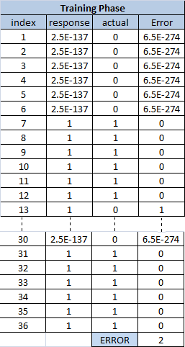
Fig 5.10.4: Error calculation

The whole implementation here is done in excel. The figure 5.10.5 shows the 2nd feature data. The index column on the left side shows the index number of data under consideration. [Along with each data in the training dataset we have an index number. See figure 5.10.4. This index term is included in order to facilitate the use of what if analysis in excel]. The value of X1, X2, X3…X6 (the elements of eigenvector) will get change automatically once we change the index value. This is done by using INDEX function in excel. It basically takes three arguments – the table range, the row of the table, column of the table and finally returns the value corresponding to that particular row and column in the table range. For E.g. The formula which need to typed in the cell corresponding to X1 can be =INDEX($A$6:$F$36,$I$7,1)where $A$6:$F$36 represents the range of cells over which the table data spans, $I$7represents the index (row) and 1 represents the 1nd column of the referred table range. The same formula is used in all the other cells except that the column value changes. The column number in the formula should be changed for each of the successive three cells ie.1 should be made 3, 4 etc.

Fig 5.10.5: Input vector
Figure 5.10.6, shows the optimized weights for the hidden layer and the output layer. These optimized weights are obtained by using “SOLVER”. E.g. the formulae corresponding to the sigmoid function is =1/(1+EXP(-1*(I12+SUMPRODUCT($J$12:$O$12,$K$7:$P$7)))) where $J$12:$O$12shows the range of input value X1,X2…X9 and $K$7:$P$7 shows the range of weights cells in excel implementation. This is typed in the response column of the hidden layer section as shown in figure 5.10.6. Once the optimum weight values are obtained the hidden layer response at the end column in obtained by taking the sum of, product of corresponding terms in the input layer X1, X2, X3, X4, X5, X6 and weights in the middle layer W1, W2, W3, W4, W5, W6 and then normalizing the value to the range [0 to 1]. This is done by using the signum function which is.
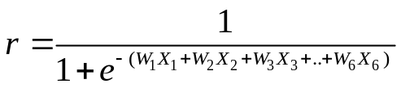
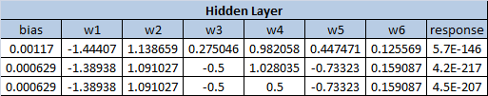

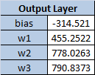
Fig 5.10.6: Optimized Hidden layer and output layer weights
Now the response obtained from the hidden layer is passed to the output later where this response is multiplied with the corresponding output layer weights, then added and normalized using the same signum function as seen in previous cases. Now the response from the output layer will be a value between 0 and 1.

Fig 5.10.7 Actual &Expected Response
It can be seen that the actual and expected value when are almost close. The response from the output layer can be conveted to 0 or 1 by thresholding . Here thersehold is set as 0.5. Anything above 0.5 will be consided a class 1 and vice versa. Thus for a particular input vector if the response is 1 then the ear is said to belong to person 1 and else it is said that it belongs to person 2.

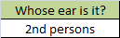
IF(response>=0.5,"Istpersons","2nd persons")

5.10.6 Testing Phase
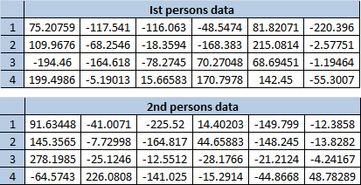
Fig 5.10.8: Testing dataset
Testing phase is where we test the extent to which the neural network has been trained. For testing all you need to do is to copy one of the training data as shown in screenshot 5.10.8 for one of the person and paste it on to the input columns of the Neural network which is implemented in the “EAR PATTERN CLASSIFICATION” tab of the implemented excel (available in attached CD). The column corresponding to the label “Whose ear is it?” will display person1 or person2 depending on the input feature given [4][6].
  - Adaptive Noise Filtering Using Backpropogation Neural Network
Let us now try out an example in signal processing domain. The signal transmitted through a channel is always susceptible to noise. So filtering out the noise component is an essential step at the receiver. The filtering out such noise component can be done only with a filter and designing a filter involves the calculation of filter coefficients (in our case we use digital, FIR filter). But here we are trying to replace the filter with a Neural Network. The only requirement being that we need to train the network suitably [1].
Let us consider a signal, x(n) transmitted through the noisy channel. Let us also assume that it gets corrupted with noise when it passes through the channel. Hence at the receiver our primary objective is denoising (removing the added noise content). For this reason we pass it through an FIR filter. Let h(n) be the impulse response of the filter. The output of filter y(n) is obtained by convolving the input sequence with the impulse response of filter [1].
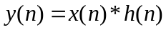
Here ‘*’ is the convolution operator. In real time this convolution of two sequences is given by time reversing any one of the sequence and then time shifting and multiplying the resulting set for N-1 times. Thus the output convolved sequence will have a length N. Here N = length of first sequence + length of second sequence -1. This process of shifting and multiplying is incorporated in the following equation. (This is the equation for real time convolution).
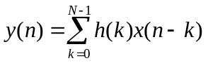
NOTE
While timeshifting and multiplying, there is no need add and multiply all the N-1 terms. Only the overlapping terms need to be multiplied. The rest of the terms can be avoided as value of one the sequence will be 0 at that point.

As far as a digital filter is concerned, the basic designing involves finding out the coefficients a0, a1, a2…b1, b2, b3… of the filter. To obtain the values there is the need to study about the nature of the noise of the channel. In practical situations the reference signal (an impulse) is sent through the channel and the corresponding signal obtained as the output of the channel is stored. These are used for determining the filter coefficients of the FIR filter. Once filter coefficients are obtained, they are used to filter the real time noisy signal at the receiver.
As mentioned above our objective is to replace the filter with a neural network. So we give the input provided to FIR filter is given as input to the neural network and the network will be trained to give an output same as what its counterpart (FIR filter) gives.
The FIR filter used here will take 11 continuous samples from the distorted signal as input at a time and convolve it with the filter coefficient. The response of the filter will be the filtered signal which is free from noise. Thus it is as if the filter is doing some manipulations on the distorted signal to obtain back the undistorted signal. Since this is the case, it is always possible to replace the filter with a neural network where the manipulation on the input to obtain the output can be done almost effectively.
5.11.1 Modeling Neural Network
Here we are considering a filter having a length N= N1+N2-1 =11. Thus at a time 11 inputs of the sampled signal are used to determine the output. For this reason there should be 11 input nodes. Here we are assuming that we only have one middle layer with 3 middle layer nodes and the output layer is expected to have an output node. Since all the input vales are numerical values less than there is no need for mapping it to other number. These variables can be directly provided to the input layer of the neural network.
5.11.2 Training Phase
For training, the basic requirement is a training data set. In the training dataset, the reference signal sample value is considered as the expected output and the noisy signal samples are considered as the input vector. In our case we have taken samples from a “.wav” file, which acts as reference samples. To distort the signal i.e. to add noise to signal, the signal is convolved with a filter with coefficient [0.707, 0.707]. Here we have the 500 input samples which are the distorted signal sample values. Also we have 500 expected output value which is the undistorted signal sample values. Now as we said earlier, at a time pervious 10 values of the distorted signals are manipulated in some way to produce the 11th value in the undistorted signal sample value. Thus for getting the training data we take some 10 continuous samples from the input sequence and the output value is selected as the next value from the output sequence (the undistorted signal). This is done for random positions of the input signal 500 times, to obtain a total of 500 training and testing data.
Once the neural network is trained, it will produce the original signal, once it gets a noisy version of the original signal.
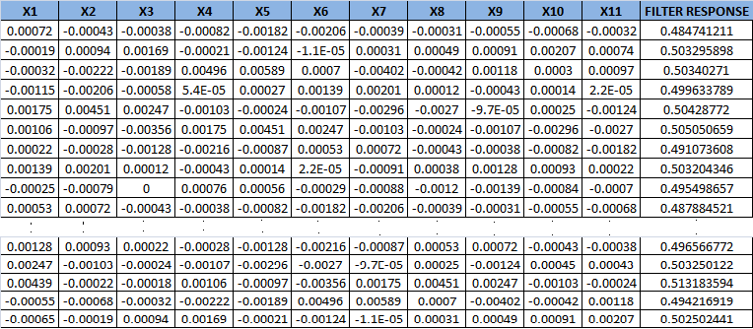
Fig 5.11.1: Training dataset

For each training data, the output of the neural network should be found out and the difference between the expected output and the actual output is computed. All the error values are then added up. Our objective is to reduce this total error so that the expected output and actual output will almost match. This is done by adjusting the middle layer weights. The whole adjustment process is explained in previous examples.

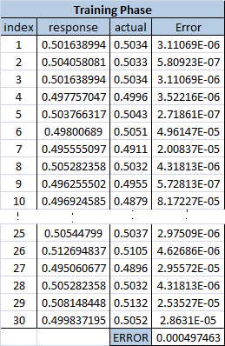
Fig 5.11.2: Error calculation

The figure 5.11.3 shows the 3st feature data. The index column on the left side shows the record the index number of data under consideration. [Along with each data in the training dataset we have an index number. See figure 5.11.2. This index term is included in order to facilitate the use of what if analysis in excel]. The value of X1, X2, X3…11 will get change automatically once we change the index value. This is done by using INDEX function in excel. It basically takes three arguments – the table range, the row of the table, column of the table and finally returns the value corresponding to that particular row and column in the table range. For E.g. The formula which need to typed in the cell corresponding to X1 can be =INDEX($A$6:$K$36,$N$7,1) where $A$6:$K$36 represents the range of cells over which the table data spans, $N$7 represents the index (row) and 1 represents the 1nd column of the table. The same formula is used in all the other cells except that the column value changes. The column number in the formula should be changed for each of the successive three cells.

Fig 5.11.3: Input feature values
Figure 5.11.4 and Figure 5.11.5, shows the optimized weights for the hidden layer and the output layer. These optimized weights are obtained by using “SOLVER”. E.g. Type the formulae corresponding to the sigmoid function is in the response column of the hidden layer as, =1/(1+EXP(-1*(N12+SUMPRODUCT($O$12:$Y$12,$P$7:$Z$7)))) where $O$12:$Y$12 shows the range of input value X1,X2…X11 and $P$7:$Z$7 shows the range weights W1,W2,W3…W11 in
the excel implementation.
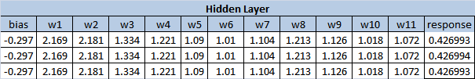
Fig 5.11.4: Optimized middle layer weights

The response obtained is passed to the next later – Output later where the this response is multiplied with the corresponding output layer weights ,then added and normalized using signum function as mentioned in previous examples.

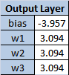
Fig 5.11.5: Optimized output layer weights

Fig 5.11.6: Actual & Expected output

In the figure 5.11.6 you can see that, for the particular set of input, the actual response and the Expected response is almost same. This shows that the network is trained.
5.11.3 Testing Phase
Once the optimum weights are found out Using “SOLVER” the network is now ready for testing, where we give inputs which are not used in training the neural network but whose output is known in prior. This is done to ensure that the network will give the correct output for any input. The testing is done using the data which we kept apart during preprocessing. Once the testing gives good results, the neural network can be deployed in place of the filter to act as a noise filter [6]. Thus the response we obtained from the filter and the response we obtain from the neural network for the same set of inputs are made same. Thus it possible to replace the FIR filter with this neural network. In the excel implementation, the training data is given in the “PREPROCESSING” tab of excel implementation. For testing all you need to do is to copy one of the training data and paste it on to the input of the neural network which is implemented in the “NOISE FILTERING” tab [The whole implementation is available in the attached CD].
  - Contact Lens Problem
Contact lenses are of different kinds, and the decision of choosing the best type for a patient can only be done by a physician. The physician comes to this conclusion by taking into account various factors. These features may be Age, spectacle-prescrip, Presence or absence of astigmatism, tear-prod-rate and lots more. If such feature values for 100 patients are available, it is even possible for us to predict to some extend what type is suitable to a new patient. All we need to do is to find a close matching record from the list and depending on the decision given in the list we can tell our decision. If we can do this a computer can do this with some effort. This can be done by machine by using some learning algorithm like SVM or Neural Network [5]. Here we have used Neural Network to make the machine learn to give out the correct decision.
5.12.1 Modeling Neural Network
Now let’s come to the designing of neural network. Here four features are obtained from patient - Age, spectacle-prescrip, Presence or absence of astigmatism, tear-prod-rate. For this reason the input layer of neural network should have four nodes to take these inputs. The output of Neural Network can have a value 0 or 1 or a value in between. In our case we have three values which could come as the output [see Table 8.3.3]. For this reason we have selected two output nodes by which maximum of four states can be represented. For this case there are four features which are taken into consideration for telling the type of contact lens suitable for a patient. The table 8.3.1 mentions about the feature variables and the input variables ans their possible values.
Prediction Variables:
Age of the patient: | (a) young  (b) pre-presbyopic  (c) presbyopic
.  Spectacle prescription | (a) myope  (b) hypermetrope
Astigmatic | (a) no  (b) yes
Tear production rate | (a) reduced  (b) normal

Table 8.3.1: Attribute Classes
Target Variable—Contact-lenses (3 classes):
1. The patient should be fitted with hard contact lenses.
2. The patient should be fitted with soft contact lenses.
3. The patient should not be fitted with contact lenses.

The designing of neural network also includes the selection of number of input nodes, which here is four for there are nine feature inputs. The number of output nodes is selected as 2 for there are only three possible classifications (soft contact lens recommended, hard contact lens recommended, cannot use contact lens). Here we are comfortable with one middle layer. As a thumb rule we usually select the average of nodes in the input and output layer as the number of nodes in the middle layer. We now have the input data (features) and now we need to assign numerical values to these input variables. Here X1, X2, X3, and X4 corresponds to the input features.
5.12.2 Preprocessing
The preprocessing mainly aims at separating out the collected data into Training and Testing sets and at the same time assigning numeric values to the prediction/input attributes as The prior said feature value cannot be directly given to the input of Neural Network. The discrete values have to be mapped into a numerical domain. Ie. A numerical value is given to each class of attributes. For this example we have assigned the class values as shown in Table 8.3.2.

Age of the patient:
  (a) young | 0
  (b) pre-presbyopic | 1
  (c) presbyopic | 2
.  Spectacle prescription
  (a) myope | 0
  (b) hypermetrope | 1
Astigmatic
  (a)Yes | 0
  (b)No | 0
Tear production rate
  (a) reduced | 0
  (b) normal | 1
Table 8.3.2: Mapping the feature data with numerical values

As mentioned earlier the output can have three values- . The patient should be fitted with hard contact lenses 2. The patient should be fitted with soft contact lenses. 3. The patient should not be fitted with contact lenses.
The patient should be fitted with hard contact lenses | 1 | 0
The patient should be fitted with soft contact lenses. | 1 | 1
The patient should not be fitted with contact lenses. | 0 | 0
Not Required | 0 | 1
Table 8.3.3: Output Feature Value & corresponding numerical mappings
The output value of the neural network is in numerical domain. So we make the above assumption and right from training the network the assumptions are made.
5.12.3 Training Phase
As for any training algorithm, the primary requirement is is valid training data. For our case the training data can be taken from physician’s patient database. For our case training data was taken from [1] . Now are all set to train the neural network. As mentioned in previous examples the training is the process of assigning suitable weights to the nodes in the middle layer/hidden layer of the network. This done with the help of solver.
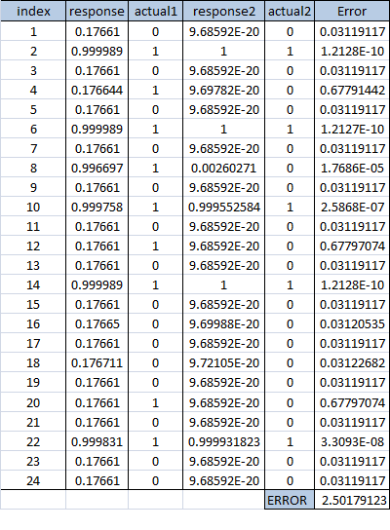
Fig 5.12.1: Error calculation

In training phase for a particular weight selection the training data is applied and the actual response of the neural network for each of the training data is calculated and compared with the expected or actual data. The difference between the actual and expected data is the error. The total error is found out by adding all the square of all the error. Here we are squaring the error in order to make all error terms positive so that they do not cancel when they are added together to get the total error causing erroneous response. In the figure 5.12.1 the total error is obtained in the last row by adding all the errorsquare values obtained in the above rows. Our objective here is to minimize the total error. This output of neural network is entirely a function of weights in the middle layer and output layer. So there would be nothing wrong if we say that the total error is a function of these weights. Now we need to adjust the weight and end up with a set of weights which will give us the minimum total error. This process of changing the weights continuously and making the error minimum is a tedious process. For our rescue “SOLVER” has the ability to do this operation. All we need to do is to inform the “SOLVER” about the location of cell where the total error is made available and the set of cells which need to be changed or readjusted in order to get a minimum error value.
The whole implementation here is done in excel. The figure 5.12.2 shows the 1st feature data. The index column on the left side shows the record the index number of data under consideration. [Along with each data in the training dataset we have an index number. See figure 5.12.1. This index term is included in order to facilitate the use of What-If Analysis in excel]. The value of X1, X2, X3, and X4 will get change automatically once we change the index value. This is achieved by using INDEX function in excel. It basically takes three arguments – the table range, the row of the table, column of the table and finally returns the value corresponding to that particular row and column in the table range. For E.g. The formula which need to typed in the cell corresponding to X1 can be =INDEX($B$7:$G$54,$J$6,2)where $B$7:$G$54 represents the range of cells over which the table data spans, $J$6 represents the index (row) and 2 represents the 2nd column of the table. The same formula is used in all the other cells except that the column value changes. The column number in the formula should be changed for each of the successive three cells ie.1 should be made 3, 4, 5.

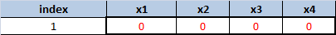
Fig 5.12.2: Input feature values

Figure 5.12.3 and Figure 5.12.4, shows the optimized weights for the hidden layer and the output layer. These optimized weights are obtained by using “SOLVER”. E.g. the formulae corresponding to the sigmoid function is =1/(1+EXP(-1*(M10+SUMPRODUCT($N$10:$V$10,$O$6:$W$6)))) where $N$10:$V$10 shows the range of input value X1,X2…X9 and ,$O$6:$W$6 shows the range weights in excel implementation. This is typed in the response column of the hidden layer section as shown in figure 5.12.3.
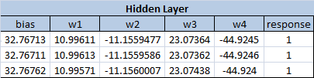
Fig 5.12.3: Optimized hidden layer weights
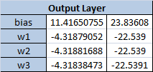
Fig 5.12.4: Optimized Output layer weights
The figure 5.12.3 shows the optimal weights for the middle layer, which is obtained for the input training data given. The response at the end column in obtained by taking the sum of, product of corresponding terms in the input layer X1,X2,X3,X4 and weights in the middle layer W1,W2,W3,W4 and then normalizing the value to the range [0 to 1]. This is done by using the following equation.
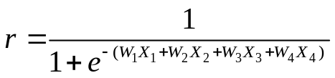
The response obtained is passed to the next later – Output later where the this response is multiplied with the corresponding output layer weights ,then added and normalized using the same equation mentioned just above. The formula used in the first column near the label “Actual value” as shown in Fig 5.12.5 is =1/(1+EXP(-1*($L$16+SUMPRODUCT(L17:L19,O10:O12)))) where O10:O12 represents the range of middle layer responses, L17:L19 represents the range of cell providing the output layer weights coming between the middle layer and the output layer, which is the last 3 row values from the first column In Fig 5.12.4. and $L$16 represents the bias term obtained from 1 row of the first column in Fig 5.12.4. Similarly the formula use in second column of the Fig 5.12.5 for obtaining the response of second output node is =1/(1+EXP(-1*($M$16+SUMPRODUCT(M17:M19,O10:O12)))) .
Fig 5.12.5: Actual and expected response
The figure 5.12.5 compares the response of the trained neural network and the expected response. You can see that they are the almost same. The output are thresholded by a factor 0.5 to values 0 or 1. The output will be [0 0], [1 1], or [0 1] and based on table 1[where a mapping a made between numerical values and corresponding logical meaning] values we come to a conclusion. I.e. What type of lens is recommended for a patient - a soft or hard contact lens, or no contact lens.
5.12.4 Testing Phase
Once the optimum weights are found out Using “SOLVER” the network is now ready for testing phase, where we give inputs which are not used in training the neural network but whose output is known in prior. This is done to ensure that the network will give the correct output for any input. The testing is done using the data which we kept apart during preprocessing. All the testing data is applied to the neural network and if the actual response matched the expected response for almost all the inputs, then this shows that the neural network is trained appropriately. Now the network is ready to accept any input feature set and determine what type of lens is recommended for a patient - a soft or hard contact lens, or no contact lens [4][6].
5.13 Breast Cancer Recurrence Prediction
ANN has proven to be a useful tool in pattern recognition and classification tasks in diverse areas, including clinical medicine. Despite the wide applicability of ANN, the large amount of data required for training makes using them an unsuitable classification technique when the available data are scarce. Magnetic resonance spectroscopy (MRS) plays a pivotal role in the investigation of cell biochemistry and provides a reliable method for detection of metabolic changes in breast tissue. The scarcity of data and the complexity of interpretation of relevant physiological information impose extra demands that prohibit the applicability of most statistical and machine learning techniques developed. Knowledge-based artificial neural networks (KBANN) help to prevail over such difficulties and complexities. A KBANN combines knowledge from a domain, in the form of simple rules, with connectionist learning. This combination trains the network through the use of small sets of data (as is typical of medical diagnosis tasks).The primary structure is based on the dependencies of a set of known domain rules, and it is necessary to refine those rules through training. The KBANN process consists of two algorithms. One is the Rules-to-Network algorithm, in which the main task is the translation process between a knowledge base containing information about a domain theory and the initial structure of a neural network. This algorithm maps the structure of an approximately correct domain theory, with all the rules and their dependencies, into a neural network structure. The defined network is then trained using the backpropagation learning algorithm. Feedback mechanisms, which inhibit or stimulate the growth of normal cells, control the division and replacement of cells in normal tissues. In the case of tumors, that process is incapable of controlling the production of new cells, and the division is done without any regard to the need for replacement, disturbing the structure of normal tissue. Changes observed in phospholipid metabolite concentrations, which are associated with differences in cell proliferation in malignant tissues, have served as the basic inputs for the identification of relevant features present in malignant or cancerous tissues but not in normal tissues. The abnormal levels of certain phospholipid characteristics are considered indicators of tumors. These include several parameters, such as PDE, PME, Pi, PCr, γATP, αATP, and βATP. KBANN produced an accurate tumor classification of 87 percent from a set of 26, with an average pattern error of 0.0500 and a standard deviation of 0.0179 [2].
For implementing the breast cancer recurrence predictor using a supervised learning algorithm such as neural network we require valid data (Valid data here implies to the feature data based on which the doctor came to a conclusion that, the there is high possibility of the cancer cells spreading again, and these prediction had come true). For our case we obtained the data from [1]. [Dr. WIlliam H. Wolberg (physician), University of Wisconsin Hospitals, Madison, Wisconsin, USA]. For effective design of a neural network we should have valid data for training phase as well as for testing purpose. For our case, we have restricted ourselves our training dataset to 50. If we had gone for 200 dataset [size of available dataset], the weight optimization using excel solver would not have been possible. The rest of the 150 datasets is used for testing once the initial phase of training the neural network is over.
5.13.1 Preprocessing
The first and foremost in the design structure of a neural network is the preprocessing of the training data. For this case there are about nine features which are taken into consideration. following list shows the training data used and the corresponding numerical mapping which is done.
Clump thickness
  20-29 | 0
  30-39 | 1
  40-49 | 2
  50-59 | 3
  60-69 | 4
Uniformity of cell size
  ge40 | 0
  Premeno | 1
  It40 | 2
Uniformity of cell shape
  0-4 | 0
  5-9 | 1
  10-14 | 2
  15-19 | 3
  20-24 | 4
  25-29 | 5
  30-34 | 6
  35-39 | 7
Marginal adhesion
  0-2 | 0
  3-5 | 1
  6-8 | 2
  9-11 | 3
  12-14 | 4
  15-17 | 5
  24-26 | 6
Single epithelial cell size
  Yes | 1
  No | 0
Bare nuclei
  1 | 1
  2 | 2
  3 | 3
Bland chromatin
  Right | 0
  Left | 1
Normal nucleoli
  Central | 0
  Left Low | 1
  Left Up | 2
  Right low | 3
  Right Up | 4
Mitoses
  Yes | 1
  No | 0
Table 5.13.1: Preprocessing of input
The preprocessing mainly aims at separating out the collected data into Training and Testing sets. For this case we have selected from the first 50 data from the dataset for training purpose. The rest is kept as testing data. The next part in the designing is the selection of number of input nodes, which here is 9 for there are nine feature inputs. The number of output nodes is selected as 1 for there are only two possible classifications (no recurrence event, recurrence event). Here we are comfortable with one middle layer. As a thumb rule we usually select the average of nodes in the input and output layer as the number of nodes in the middle layer but here we have selected slightly more than the average value. We now have the input data (features) and now we need to assign numerical values to these input variables. The figure 5.13.1 shows the first ten feature data. It explain how the input feature values are mapped to corresponding numerical domain. Here X1, X2, X3... X9 corresponds to the input features.
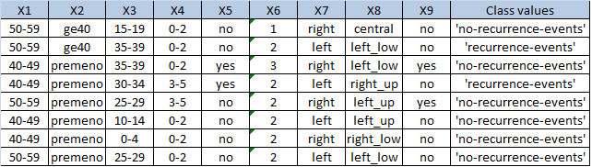

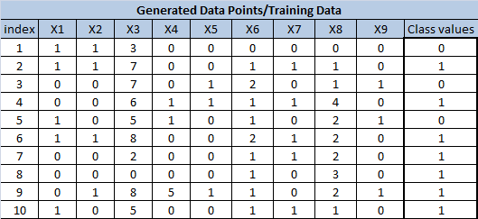
Fig 5.13.1: Mapping feature values to numerical values
The next part is to initialize the weights in the middle layer. It is possible that the depending on the initial weights chosen the error function might converge to local minima or global minima.
5.13.2 Training phase
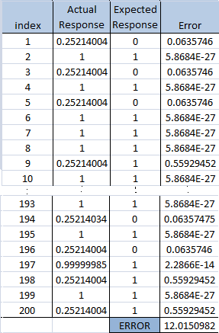
Fig 5.13.2: Error calculation
In training phase for a particular weight selection the training data is applied and the actual response of the neural network for each of the training data is calculated and compared with the expected or actual data. The difference between the actual and expected data is the error. The total error is found out by adding all the square of all the error. Here we are squaring the error in order to make all error terms positive so that they do not cancel when they are added together to get the total error causing erroneous response. In the figure 5.13.2, the total error is obtained in the last row by adding all the errorsquare values obtained in the above rows. Our objective here is to minimize the total error. This output of neural network is entirely a function of weights in the middle layer and output layer. So there would nothing wrong if we say that the total error is a function of these weights. Now we need to adjust the weight and end up with a set of weights which will give us the minimum total error. This process of changing the weights continuously and making the error minimum is a tedious process. For our rescue “SOLVER” has the ability to do this operation. All we need to do is to inform the “SOLVER” about the location of cell where the total error is made available and the set of cells which need to be changed or readjusted in order to get a minimum error value.
The whole implementation here is done in excel. The figure 5.13.3 shows the 21st feature data. The index column on the left side shows the record the index number of data under consideration. [Along with each data in the training dataset we have an index number. See figure 5.13.2. This index term is included in order to facilitate the use of what if analysis in excel]. The value of X1, X2…X9 will get change automatically once we change the index value. This is done by using INDEX function in excel. It basically takes three arguments – the table range, the row of the table , column of the table and finally returns the value corresponding to that particular row and column in the table range. For E.g. The formula which need to typed in the cell corresponding to X1 can be =INDEX($A$7:$K$206,$M$6,COLUMN(B1)) where $A$7:$K$206 represents the range of cells over which the table data spans, $M$6 represents the index (row) and COLUMN(B1) is an alternative way used to specify that the data belonging to the 2nd column of the table should be taken. The same formula is used in all the other cells except that the column value changes i.e. COLUMN (B1) will be changed to COLUMN (C1) and so on.
Fig 5.13.3
Input feature values
X1, X2…XN are the input feature values. These are then multiplied by the weighs in the middle layer and then they are normalized to the range [0 ,1] by sigmoid function.

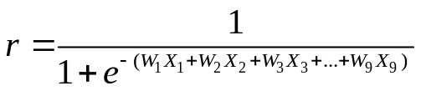
Where r is output of a node in middle layer, W1, W2…WN are the corresponding weights. Figure 5.13.4 and Figure 5.13.5, shows the optimized weights for the hidden layer and the output layer. These optimized weights are obtained by using “SOLVER”. Eg.The formulae corresponding to the sigmoid function is =1/(1+EXP(-1*(M10+SUMPRODUCT($N$10:$V$10,$O$6:$W$6)))) where $N$10:$V$10 shows the range of input value X1,X2…X9 and ,$O$6:$W$6 shows the range weights in excel implementation. This is typed in the response column of the hidden layer section as shown in figure 5.13.4.
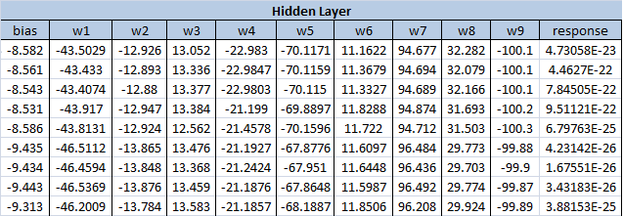
Fig 5.13.4: The Hidden Layer Implementation
The response of the middle layer is again multiplied by the output layer weights and then normalized by sigmoid function. This forms the response of the neural network. Here the response will be a value in the range [0, 1].
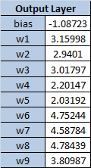
Fig 5.13.5: Optimized output Layer weights
The formula used in the response is =1/(1+EXP(-1*($S$21+SUMPRODUCT(S22:S30,W10:W18)))) where S22:S30 is the range of output weight values and W10:W18 is the range of response output we obtained from the middle layer.
Fig 5.13.6: Obtained &Actual response
Now our objective here is to test whether the actual response almost matches the expected response. The figure 5.13.6 shows that for the particular set of weights the expected response and the actual response is almost same. If the response for all set of input is almost matching, then the total error is minimized. This means that the system is now able to classify correctly [6].
Now depending on the response value we need to print the corresponding output (Here it is the “Yes” or “No”). This is obtained by printing “Yes” if the response of greater than 0.5 and else the response is printed as “No”.
5.13.3 Testing Phase
Initially we have kept apart some data for testing purpose. This data can be directly applied in the X1, X2…XN cells and the corresponding response can be obtained as “Yes” or “No”. If most of the actual and expected responses are same. Then we can come to a conclusion that the neural network is trained to the expectation. Thus the application would be able to decide the Breast cancer is recurrent type or not, depending on the response of the neural network.
5.14 Summary
In this chapter we have provided step-by-step implementation of data mining problems using Artificial Neural Networks in Microsoft Excel. We first introduced the basic problems like XOR, circle, Spiral, Sin function with help of ANN and later explained some real life problems like Eigen ear, contact lens, time series analysis etc.

References
[1] E.S. Gopi, “Algorithm Collection for Digital Signal Processing Application”, Springer, 2007.

[2] Marina Gorunescu, Florin Gorunescu, Marius Ene, and Elia El-Darzi, “A heuristic approach in hepatic cancer diagnosis using a probabilistic neural network-based model”

[3] C. Bishop. Neural Networks for Pattern Recognition. Oxford University Press, 1995.

[4] Ragsdale, C. T. and Zobel, C. W. (2010), A Simple Approach to Implementing and Training Neural Networks in Excel. Decision Sciences Journal of Innovative Education, 8: 143–149. doi: 10.1111/j.1540-4609.2009.00249.x

[5] Soman, K.P., Loganathan, R., Ajay, V. Machine learning With SVM and Other Kernel Methods. Published by PHI Learning Private Limited. ISBN:978-81-203-3435-9

[6] Neuralyst:Version 1.4- User’s Guide, CHESHIRE ENGINEERING CORPORATION

